

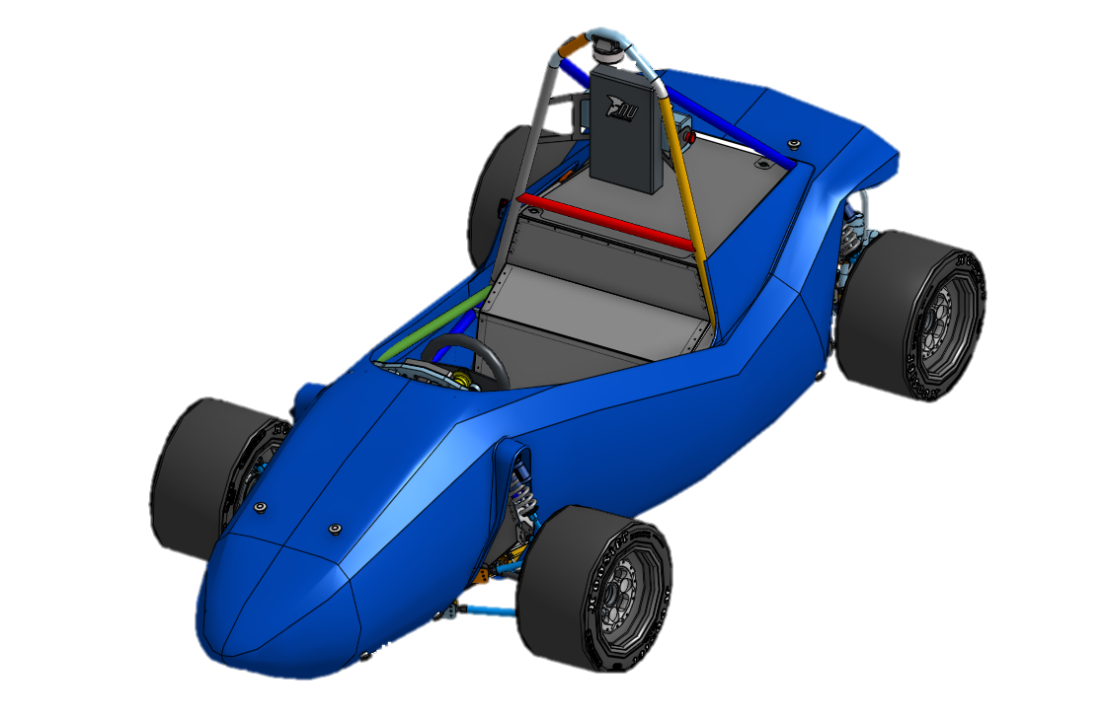

**Chief Mechatronic Engineer**

Directed Reading

NU24

Alec Chapman

2024

Contents

List of Figures iii

List of Tables iv

Abstract 1

Introduction 2

The Role of Chief Mechatronic Engineer 2

The Leadership Aspect of the Role 2

The State of the Art 4

Mechatronic Team Management and Design 6

The 2024 Mechatronic (MCHA) Team 6

The Budget 7

Start of Year Assessment 7

NU24 Changes 8

NU24 Design, and Testing: 10

NU24 LV System Integration and Test on NU23 11

Cascadia CM200DZ Propulsion Inverter Failure 14

Background and Inverter Failure 14

Fault Finding and the Purchase of a New Inverter 14

CM200DX Integration and Noise Troubleshooting 16

Electrical System Form (ESF) 18

Cost 19

The Cost Report 19

PCB 20

Looms 20

Assemblies 20

All Other Components 21

The Cost Scenario: 21

The Cost Event 22

NU24 Testing 23

Technical Inspection 32

Overview 32

Accumulator Tech 33

EV Static (EV1) 35

EV Functional (EV2) 35

Rain Test 36

Competition 36

2024 FSAE-A Competition 37

Conclusions and Recommendations 38

References 39

Appendix 40

NU23 LV Systems 40

Detailed Design Review (DDR) 44

NUCAN Zero-To-Hero 51

2024 ESF 56

Cost Report 70

The Cost Scenario Presentation 134

The MCHA Technical Inspection Bible: 140

# List of Figures

Figure 1 Presenting the Engineering of the Month Award for October to Josh Hayward (RIGHT) 3

Figure 2 NU23 LV Topology and the position of the Nodes 4

Figure 3 NU23 Shutdown Circuit 5

Figure 4 2024 NU Racing MCHA Start of Year Budget (does not include Driverless) 7

Figure 5 NU24 LV Topology 9

Figure 6 NU24 Shutdown Circuit (found on GitHub) 10

Figure 7 The MCHA team working on Looms in the new MCHA Lab 11

Figure 8 The Team Diagnosing the Voltage Drop 12

Figure 9 Tim Kerr getting ready to drive NU23 with the new LV System 13

Figure 10 SMSP Test Day, NU23 Final Drive 13

Figure 11 Cascadia CM200 Inverter 14

Figure 12 Josh Hayward receiving the new CM200DX 15

Figure 13 Resolver Tuning with CM200DX 16

Figure 14 NU24 Bench Testing 16

Figure 15 Early Morning Zoom call with Cascadia, Josh Hayward and Jacob Lukes 17

Figure 16 Lachlan Fisher and the Author during Cost at FSAE-A 2024 22

Figure 17 NU24 at First SMSP Track Day 23

Figure 18 SMSP Track Day Crew 24

Figure 19 Testing on SMSP Skid Circuit 25

Figure 20 High Current Trace Damage on HIP PCB 25

Figure 21 NU24 Driving Under the Lights 26

Figure 22 Heading out to Test Spring Rates 26

Figure 23 Skidpad Training at SMSP 27

Figure 24 NU24 Presented at the NU Teams Expo 28

Figure 25 NU24 Last SMSP Track Day before Competition 28

Figure 26 Fault Finding the broken DCDC without Success 29

Figure 27 New DCDC Commission 29

Figure 28 NU24 Final Carpark Drive 30

Figure 29 The Author Pictured with NU24 at the NU Teams Expo 31

Figure 30 Team Conducting First Technical Inspection in August 32

Figure 31 FSAEA 2024 Accumulator Technical Inspection 34

Figure 32 NU23 LV Topology 40

Figure 33 NU23 Shutdown Circuit Schematic (found in NU23 GITHUB) 42

Figure 34 NU24 Shutdown Circuit Schematic (found in NU24 GITHUB) 42

Figure 35 build_cpp_from_dbc.py Script 51

Figure 36 NU23 DBC file in Kvaser Database Editor 52

Figure 37 EV3_CAN.h Defined in CEN CODE 53

Figure 38 NUCAN Variables in CEN CODE 54

Figure 39 NUCAN initialised in CEN CODE 54

Figure 40 Using NUCAN_read in CEN CODE 54

Figure 41 Using NUCAN_write in CEN CODE 55

Figure 42 Using NUCAN_heartbeat in CEN CODE 55

# List of Tables

Table 1 Comparison Between EMRAX 188 HV and 228 MV 8

Table 2 CM200 Unit Comparison 15

# Abstract

Proposed report layout:

* Abstract
* Introduction
* The state of the art
* NU24 Mechatronic team management and high-level design
* Cascadia CM200DZ Failure
* ESF
* Cost Report
* NU24 Testing
* Technical Inspection
* 2024 FSAE-A Competition
* Conclusion and Future Recommendations
* References
* Appendix

Target audience

Up and down in the leadership?

Some for leaders, some for mcha lead

Maybe highlight major things to deep drive, only do light for the rest

Something I did explicitly and something where I mentored others do this a thing (leadership) in depth

Department leader role (leader, not mcha)

Documentation is important but chose whats useful

# Introduction

This report details the observations and events of 2024 as NU Racing’s Chief Mechatronic Engineer, as well as recommendations and key points for future Mechatronic Department Leads. It is assumed that the reader has a good understanding of NU Racing’s electric cars, including the major components and the PCBs on the car.

NU Racing is a small Formula Student team, one which centres itself around hard work, determination and the special chemistry created by the team, supported by the University’s valued staff members.

In recent years, NU Racing has overachieved considering both the team size and the budget size, and historically has run high risk teams, trying to do too much each year. This has almost ended in heartbreak but hasn’t thus far, even considering an accumulator fault during 2023 Endurance, the team still scored three second place trophies and finished 7th overall.

2024 was the year of change, with a smaller team of final year students, more reliance on directed and extracurricular members, and the academic advisor, Dr Alexander Gregg departing the university. It was the first year to be handed a car capable of a podium at the Australasian Formula SAE event.

## The Role of Chief Mechatronic Engineer

The author was lucky enough to be one of the critical members of the team as Mechatronic Department leader. This included being responsible for:

* The mechatronic team and their growth in the team
* Working with the constrains set by the Team Leader and Chief Engineer
* Working with the Mechanical Department Lead
* The delegation and management of mechatronic scopes and projects
* The Mechatronic Budget
* All the mechatronic components used in the team
* Competition documents (ESF, ESO/ESA)
* The mechatronic aspects of the Cost Report, Design Event and Technical Inspection
* Regular Track Day Attendance
* Mechatronic Testing
* Mechatronic Performance and Safety at Competition

This role has evolved and adapted over the years and now as the team grows it is becoming more and more developed. It has shifted away from heavy technical work with a small amount of management to something that focuses more on management than in-depth technical work and that is what the author experienced.

It is vital for the role that a broad perspective is taken with every decision, as choices will affect other mechatronic systems, as well as mechanical systems. When in-depth attention is needed for an extended period of time on a system, it is vitally important to delegate.

## The Leadership Aspect of the Role

The role is both a technical and leadership role, both being equally important.

At the end of the day, the team is made of undergraduate engineers who are in the team to learn, and it is important to be considerate of everyone. Asking too much of people will only make them harder manage. It is also recommended to scope out the projects for the mechatronic team based on the member’s interest in the project, as they are more likely to be self-motivated, reliable and positive.

Self-awareness is very important in the role as it is very demanding and burn out is likely if safeguards and limits are not set in place. The limit of knowledge must also be accepted as making a rash decision is much worse than asking for help, this also goes the other way. Newer members will be inexperienced, and it is important for members to upskill, this only happens when members do the work. Help should be given when asked but ideally in a way which is informative rather than just suppling the answer. Talk about doing IP visits and stuff too.

It is important to be a warm and welcoming member of the team, as the team will work better if members are social and fond of each other, rather than just present in the team for experience or course credit. This is the chemistry which separates NU Racing from other teams. Checking in on members should also be done, not just on technical work but also administrative to ensure they are staying up to date with what is needed from the Team Leader.

Once the team is established and its members are getting comfortable with their position in the team, more trust must be given, as more will be required out of the department leads as competition approaches, and more so, time will be needed to oversee and check the work as a whole system. This will allow for issues to be found faster and ideally fixed before becoming destructive and time consuming.

The year can fly by quickly, so the author also recommends using a journal explicitly for NU Racing, this was something that helped the author switch off at the end of the day as well as remember all the necessary details for record and future action. The end of the year and the build up to competition is very high pressure and it is important for a level head to be kept, ideally, the leaders are the calm in the chaos of competition.

Overall, the role is very exciting and offers a very valuable experience hard to find as an undergraduate engineer. As challenging as it is, it is extremely rewarding, especially if a career in leadership is to be considered.

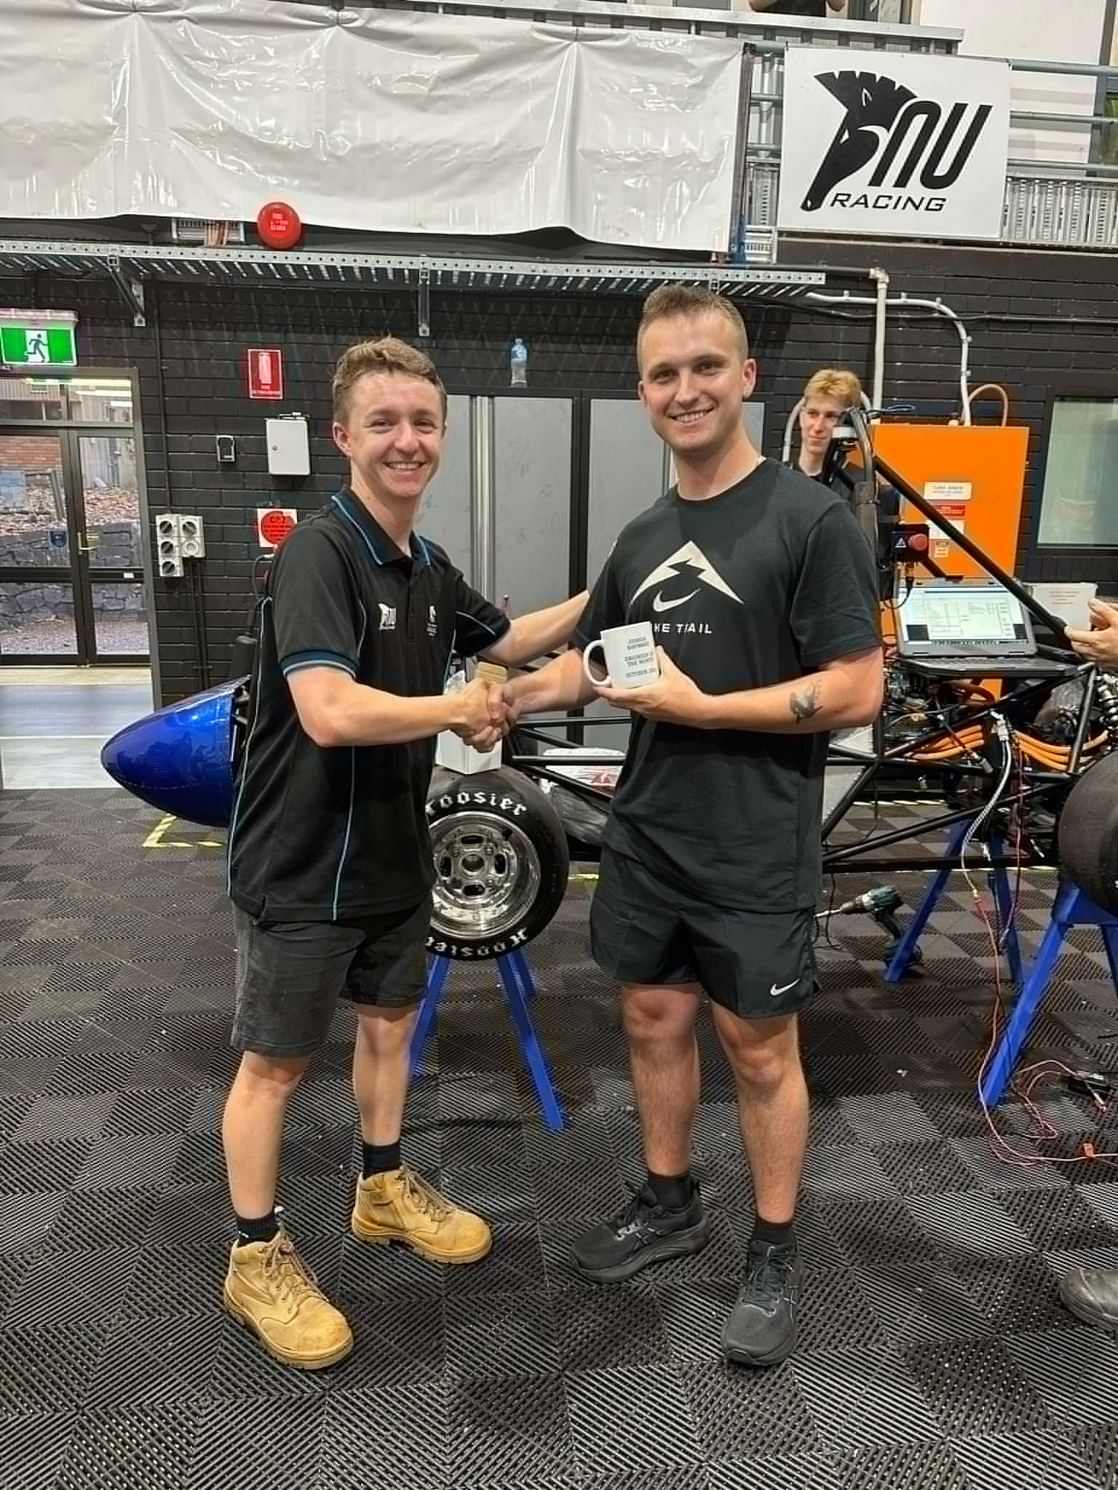

Figure 1 Presenting the Engineering of the Month Award for October to Josh Hayward (RIGHT)

# The State of the Art

NU23 was built in 2023 by NU Racing. It completed almost 450 km of testing and was a very competitive platform to begin with.

This car featured, Teensy 4.0 Microcontrollers, a 7.2 kWh 453.6 V Accumulator, capable of discharging 180 A, a 60 kW Emrax 188 AC Motor and a Cascadia CM200DZ inverter, propelling the car to 2nd place in both Skidpad and AutoX during the 2023 competition.

The accumulator is comprised of 108 Enepac Li1x6pVTC6 modules connected in series, monitored by an Orion BMS2 and our own temperature monitoring device, the CANaMON, a PCB which converts Analogue temperatures onto the CAN BUS. It also features the Low Voltage Distribution board (LVD), Precharge Board and Insulation Monitoring Device, the BENDER ISOMETER IR155-3203.

The low voltage system on the car has a nominal voltage of 12 V and is comprised of multiple individual nodes situated in the car, these include:

* The Pedal Electronic Node (PEN): Reads the Brake Pressure Sensors, Accelerator Pedal Position Sensors (APPS), and Brake Over Travel Switch (BOTS)
* The Dash Electronic Node (DEN): Reads the Dash E-Stop and Ready-To-Drive (RTD) button, and relays PEN signals.
* The Central Electronic Node (CEN): Reads the Tractive System Master Switch (TSMS), Hard Fault Latch (HFL), Top E-Stops, HV and HV Disconnect (HVD) Interlocks, Brake System Plausibility Device (BSPD), Tractive System Active Light (TSAL), OK High Signals (OKHS) and Discharge Relay. Communicates to the DCDC, Motor Controller, REN, and Accumulator. (This board also is HV)
* Rear Electronic Node (REN): Read the Temperature Sensors of the Radiator, and relays Power to the Brake Light, RTD Sounder and Cooling Pumps and Fan.
* Low Voltage Distribution (LVD): Relays Power to the Accumulator Fans and Communicates Accumulator Temperatures from the Battery Monitor System (BMS) to the CEN as well as BMS OKHS. (This board also is HV)

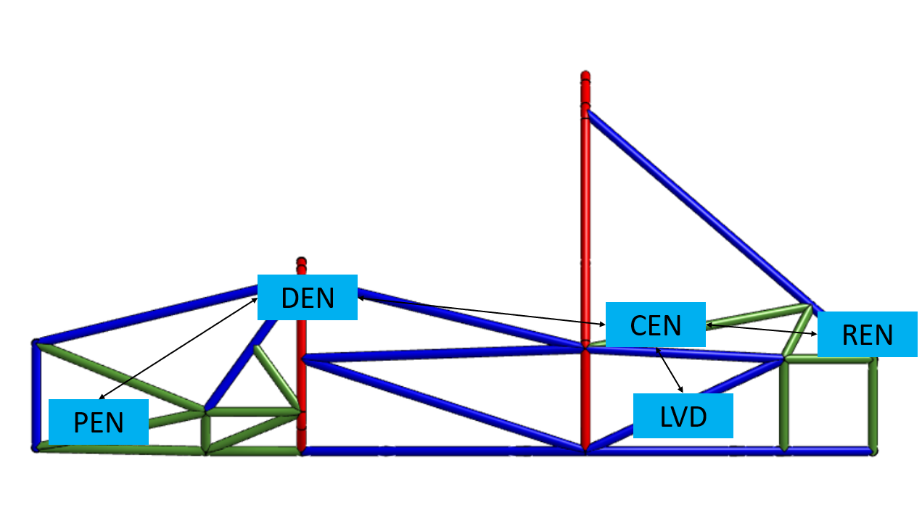

Figure 2 NU23 LV Topology and the position of the Nodes

This system was reliable, apart from the issue which stopped the car during the 2023 Endurance. The fault originated 2 weeks before competition, with no time to properly investigate and fix due to a fault with the old Bamocar inverters (details in Jye Hollier’s and Jacob Bush’s FYP reports), the car also completed a full test day between the fault and the competition, making it unpredictable. Before the 2024 final year project (FYP) members started, Jacob Bush who was 2023’s Chief Mechatronic Engineer was about to identify and recreate the issue on the LVD, which was shorting 5 V to ground whenever the accumulator management system (AMS) Active High Signal (OKHS) went bad. A fix was designed for the next iteration of the LVD.

The only ongoing unresolved issue was a BMS fault, which at the time had only occurred twice and at random instances, making it hard to replicate and investigate.

The shutdown circuit is the car’s safety signal, everything along the circuit must be good for the car to enter and stay in HV, if something goes bad, the car drops out of HV to ensure the safety of the team and the cars components.

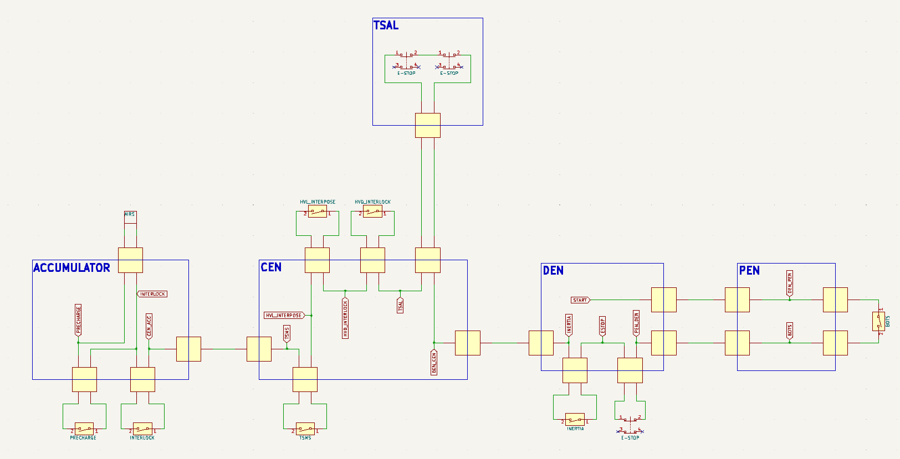

Figure 3 NU23 Shutdown Circuit

This shutdown circuit remained mostly unchanged from the 2022 car EV3. More detail of the car’s shutdown circuit can be found in NU23 LV Systems in the Appendix, as well as information on the car’s Hard Faults.

NU23 was not traction limited so did not feature any form of torque limits, and did not feature regenerative braking either.

At the end of 2023, two new EMRAX 228 MV AC motors were ordered for the 2024 team, in hope of having excess torque and power as the EMRAX 188 HV where the bottleneck in NU23’s drivetrain.

# Mechatronic Team Management and Design

## The 2024 Mechatronic (MCHA) Team

The 2024 Team as a whole was smaller then 2023, with the mechatronic team being the worst off. The 2024 MCHA team consisted of three FYPs, two directed readings and one extracurricular, only one FYP and directed readings were MCHA by degree, with the other-directed reading and extracurricular as ELEC. This meant that an AERO and a MECH were needed to make up the numbers. These were selected based on their prior course knowledge and involvement within the team.

As the FYP’s are required to be around the most, the most critical roles were selected for them, followed by the directed readings and the extracurricular.

* Powertrain Engineer – Josh Hayward (MCHA) (FYP)
  + Major components: Motor controller, Motor and BMS
  + Scope: Ensure Cascadia MC is currently configured, implement new EMRAX 228 AC motor, implement torque and power limiting and REGEN.
* Accumulator Electronics – Daniel Iveson (MECH) (FYP)
  + Major components: LVD, Precharge, CANaMONS, Cells
  + Scope: Implement updates to LVD, commission 2024 accumulator, fault find BMS comp issue, improve accumulator serviceability, Accumulator indicator light (AIL) and investigate a new Precharge board.
* LV Engineer – Jackson Boustany (AERO) (FYP)
  + Major components: Sensors, DEN, Looms
  + Scope: Implement steering angle sensors and shock pots using a CANBUS expansion board, redesign DEN to custom fit of NU24 Chassis, make/alter looms to fit NU24 including grounding and other compliance requirements
* CEN Engineer – Jacob Lukes (ELEC) (Directed SEM1)
  + Major components: CEN Motherboard and breakout boards (taking over from Jacob Bush)
  + Scope: Design new Motherboard and commission with new breakout boards and HIP
* HIP Engineer – Marisa McLean (MCHA) (Directed SEM1)
  + Major Components: HIP
  + Scope: Design new HIP PCB with intent to fit enclosure (Kieran Burgess designed the enclosure)
* PEN Engineer – Eliza O’Donnell (ELEC) (Extra)
  + Major Components: PEN PCB
  + Scope: Design new PEN PCB to fit the NU24 Pedal box (designed by the author)

The main goal of the 2024 MCHA team was to have the NU24 LV system running on NU23 before NU24 is a rolling chassis. This would speed track integration of NU24, only having the worry about the Powertrain with the new motor.

It was thought that the team would be able to complete their respective aspects of the Cost Report, Design Event and Technical Inspection as they complete their work, but due to the decreased team size, the individual workload increased, making it harder to finish everything with time to spare. This meant that these were completed close to the due date of these events, normally in a rush.

Due to the team size, it was critical that only necessary and easy projects were undertaken, as it was very high risk to overextend this year. This also allows time and funding to be allocated for unknown problems that occur throughout the year.

## The Budget

The budget for 2024 was larger than 2023 due to its success and NU Teams allowing more funding. It is the responsibility of the department leaders to create their proposed budgets and thus it is better to start with more than what is needed and to slowly reduced.

Float is critical and should be calculated into each project with projects classified into necessary, high value, medium value and low value to ensure that nothing vital is underfunded.

Once the desired changes for the year are selected, the cost of each should be estimated to the best possible accuracy before the float is added. To do this the author recommends going through last years purchase orders, seeing the total spent as well as the spending across each category. For things which have not been done before research is necessary.

It is much harder to add to the budget after the fact than to overestimate and have money left over. This needs to be worked out as soon as possible with the other leaders under the guidance of the Team Leader, as they will be the one asking for the money.

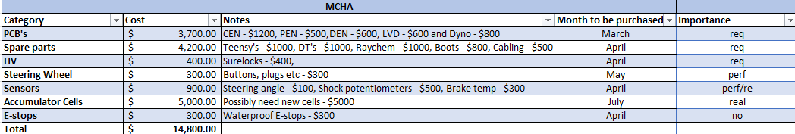

Figure 4 2024 NU Racing MCHA Start of Year Budget (does not include Driverless)

It is recommended that the budget is checked through the year, with higher frequency nearing the end, ensuring all costs are added, with remaining costs still to come.

## Start of Year Assessment

As something that was poorly done in 2024 that potentially cost the team greater success at the 2024 competition, a ‘stock count’ should be conducted. It is important that during the hand over from leadership from one year to the next, all assets are known as well as where they are stored.

Ideally the new team should go through all NU Racing property and reorganise it. Its id very normal that things are misplaced in the heat of Competition, so it is likely that things go missing.

It is highly recommended that spare parts of critical components are kept in a realistic amount. All PCBs should have spares, especially PCBs which won’t or might not change throughout the year. Ideally vital components like motors, motor controllers, cells, the BMS, the MoTeC display and DCDC have spares, as these components normally have long lead times and in both 2023 and 2024, having a spare of these components ready would have increased testing time as well as competition performance.

## NU24 Changes

The biggest change to NU24 from NU23 MCHA is the upgrade of the motor, the new EMRAX 228 MV produces more than double the power and torque of the old EMRAX 188. This new motor is significantly larger but due to that fact, it less strained for our usage compared to the 188.

Table 1 Comparison Between EMRAX 188 HV and 228 MV

|  |  |  |
| --- | --- | --- |
| Motor | EMRAX 188 HV | EMRAX 228 MV |
| Power Output (kW) | 60 | 124 |
| Torque Output (Nm) | 100 | 230 |
| Weight (kg) | 7.9 | 13.5 |
| Maximum Current (A) | 190 | 360 |

Although, it is the author’s opinion that an Emrax 208 should have been selected, the 228 provides as massive upgrade for NU Racing. For the first time, NU Racing has a motor capable of producing more power than the FSAE EV competition rules (80 kW), and will have the potential to be traction limited, rather than torque limited. This is the only Tractive System (HV) upgrade for NU24.

This upgrade was selected by the 2023 team and the 2024 leadership agreed. The remainder of the MCHA changes were selected by the author as the most experienced active MCHA team member.

It is vital that any changes are carefully thought out and selected with various reason to why the change is necessary and/or worth it. I would recommend making a Decision Matrix in 2025 that should be used for all large and medium changes on the car, both MECH and MCHA. It is also important to consult with any previous NU Racing experts on the changes, as well as the academic advisor and Malcolm Sidney, more perspectives are always useful and will ensure the correct decision is made.

When making a change, all the below need to be considered to ensure compliance and performance is static and dynamic events, as well as safety:

1. The current FSAE-A Rules and Addendum
2. Technical Inspection (use the most recent version, normally released early November so use the previous years is what should be used)
3. Design Event – Every design must include process, analysis, validation, understanding and resources for the event.

All of these need to be cross referenced with each other when selecting a change.

Due to the LV system being robust and reliable, the idea for NU24 was to only make incremental improvements for these boards, only change shape to fit the new chassis and to add simple, easy to test functionality. The exception to this was the CEN and REN.

Due to the complexity and size of the CEN, it was extremely difficult to alter and work on during testing. This resulted in the decision to separate the complex circuitry onto separate breakout boards (developed by Jacob Bush), a central mother board (developed by Jacob Lukes) and an interface/High Voltage board, the HIP (developed by Marisa Mclean).

The functionality of the BSPD and HFL was moved onto the individual breakout boards which connect to the motherboard and the HV functionality, TSAL and Discharge was combined into a single breakout board and connected to the HIP. As these separated circuits were analogue, only one teensy was required.

Another change from 2023 would be combining the functionality of the REN into the CEN motherboard as the REN with its board mounted brake light was deemed over complicated. This moved the sounder, cooling control and brake light switching onto the motherboard. The radiator coolant temperature sensors were also removed

NU24’s LV topology now includes:

* The Pedal Electronic Node (PEN): Reads the Brake Pressure Sensors, Accelerator Pedal Position Sensors (APPS), and Brake Over Travel Switch (BOTS)
* The Dash Electronic Node (DEN): Reads the Dash E-Stop and Ready-To-Drive (RTD) button, MoTeC connection, MoTeC button and relays PEN signals.
* The Central Electronic Node (CEN): Hard Fault Latch (HFL) breakout board, Top E-Stops, Brake System Plausibility Device (BSPD) breakout board, OK High Signals (OKHS), Cooling and brake light switching, sounder and LV Power distribution.
* The Human Interface Panel (HIP): Switches on LV Power, Tractive System Master Switch (TSMS), HV Disconnect (HVD) Interlocks, Test Points and Tractive System Active Light (TSAL) and Discharge Relay Breakout board. (This board also is HV)
* Low Voltage Distribution (LVD): Relays Power to the Accumulator Fans and Communicates Accumulator Temperatures from the Battery Monitor System (BMS) to the CEN as well as BMS OKHS. (This board also is HV)

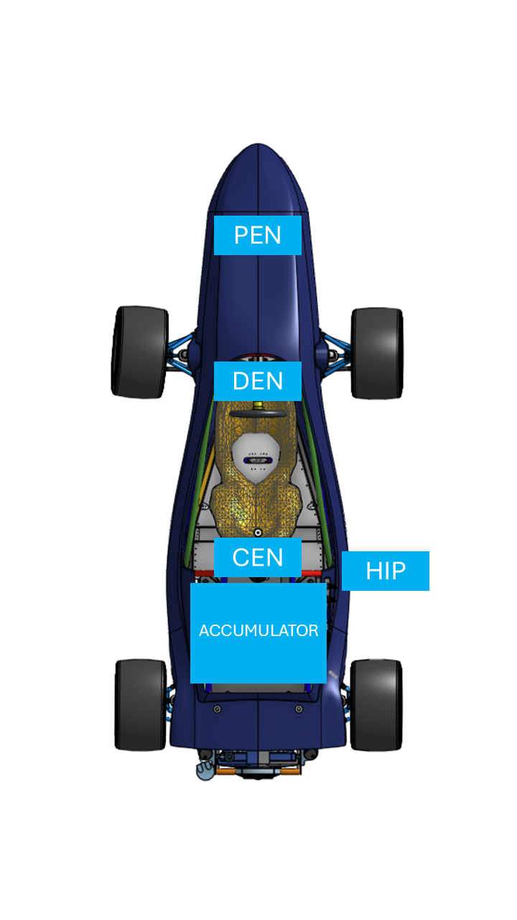

Figure 5 NU24 LV Topology

At the 2023 accumulator technical inspection, the team had trouble proving compliance with the 2 pin HV Autosport connector used on the main tractive path. To ensure this would not occur again, the team decided to change connectors. With this the team interpreted rules change incorrectly, choosing new HV connectors without an inbuilt interlock, thus removing the HV connector interlock from the shutdown circuit.

It was also believed that the interpose relay in the HFL was also not compliant and redundant, thus it was also removed from the initial design of NU24. The Shutdown start was also moved to the PEN, as in NU23, it was travelling directly from the DEN to the PEN already. This resulted in a simplified and rearranged shutdown circuit.

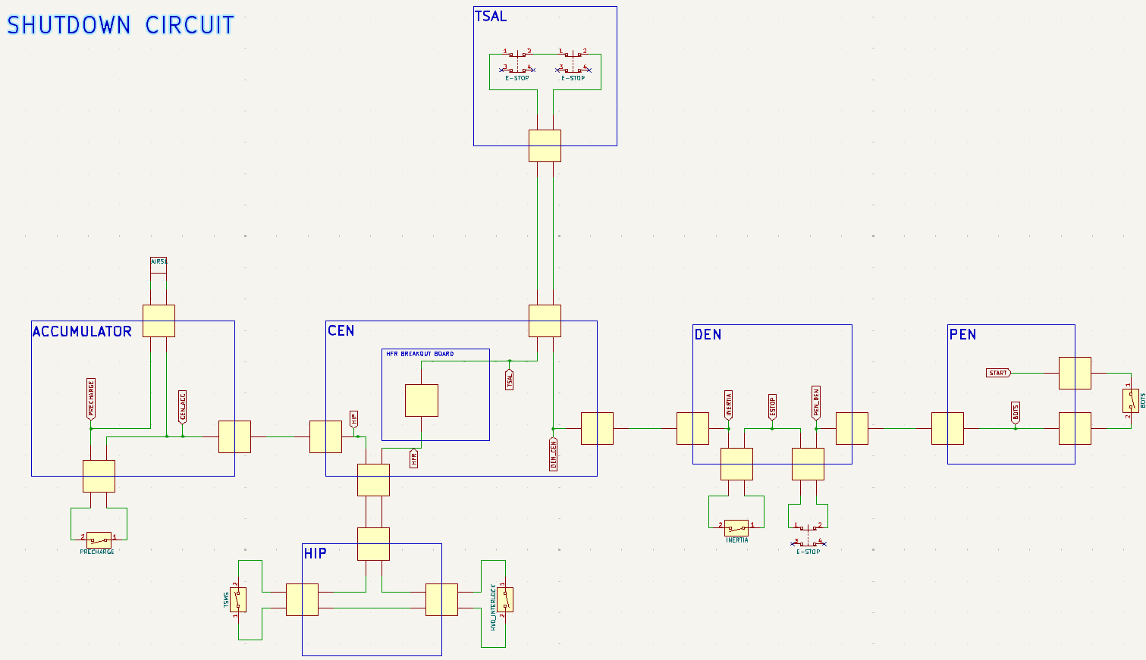

Figure 6 NU24 Shutdown Circuit (found on GitHub)

## NU24 Design, and Testing:

To ensure that the team met the required criteria for each of their systems, their projects were scoped out, documenting the required steps, checkpoints and deliverables. Due to the size of the team and the ever-changing requirements from NU Teams, the goals and deadlines of the projects were regularly changed to setbacks and were recorded by the author in a shared document with the other leaders.

Each team member was encouraged to ask for as much help as possible including from their teammates, as were regularly checked up on by the author, ensuring that everyone was on track and had everything they needed.

As majority of the design work consisted of PCBs which have lead times and are manufactured in China, a system of ensuring design quality was created. Thus, the Detailed Design Review (DDR) was created by Robert Stanley in 2023. This was extremely detailed and long and due to that, was only used by a few team members.

Before the new 2024 team start the author and Marisa McLean, who had used the DDR in 2023, updated the DDR. This version was streamlined and much simpler, allowing for team member to run through the document themselves before getting it checked with a senior MCHA. This system still ensured that nothing was missed and caught problems before commissioning.

The DDR has multiple sections, as well as places for notes about issues with prior versions and improvements for new boards, as well as commissioning steps, unit testing. The major parts during design are the schematic and layout, which correlate to the KiCAD design stages, which help reduce time fixing errors as the team member needs to pass everything on the schematic before doing the layout. The update DDR is found in Detailed Design Review (DDR) in the Appendix.

Once the new PCBs were ordered, team members would then think about commissioning the new boards, and as the car uses NUCAN, team members would need to learn how to use it. Thus, the author created a NUCAN Zero-To-Hero. While not on the Wiki or not made to the same standards of existing Zero-To-Heros (ZTH), it was decided by the author that the short form explanation would be sufficient as there is not too much information to convey.

This document outline what all the functions within NUCAN do as well as using the GitHub Repository, automated DBC editor software. It also builds from the CANBUS ZTH which is a pre-requisite. The NUCAN Zero-To-Hero can be found in the Appendix.

This helped both NU Racing and NU Marine member who also use CAN BUS and NUCAN.

The in-depth design and testing of the individual board can be found in the reports of the responsible team member.

## NU24 LV System Integration and Test on NU23

Due to the hard work of the MCHA team, the NU24 LV System was ready to test on NU23 before the end of May.

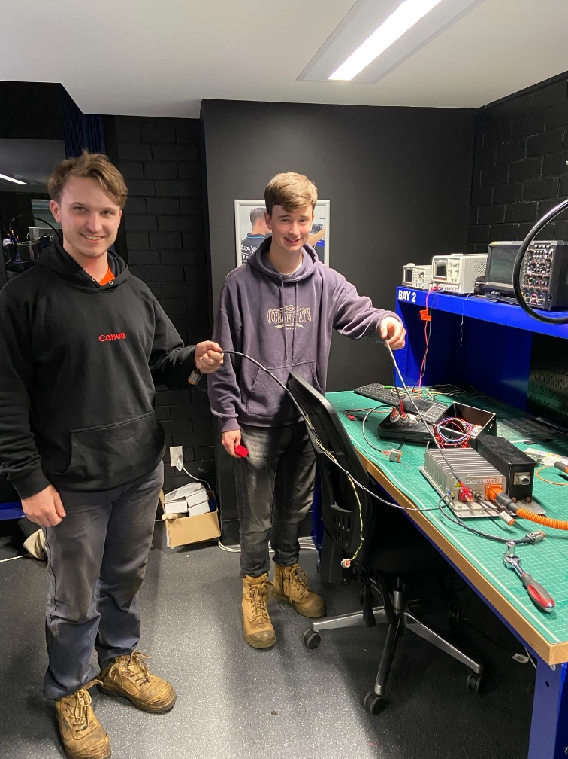

Figure 7 The MCHA team working on Looms in the new MCHA Lab

The team experienced the first late night of the year while integrating the system on NU23, running into a problem with the shutdown circuit. Due to the removal of the interpose relay on the HFL, the voltage drop across the car was too great, and the shutdown circuit could not close the AIRs, allowing the car to go into HV. Once diagnosed, the problem was patch fixed by using an automotive relay, spliced into the shutdown circuit to boost the voltage, allowing the AIRs to close and the car to go into HV, the car operated correctly and spun the wheels on the stands, ready to drive the next morning at a car park test day.

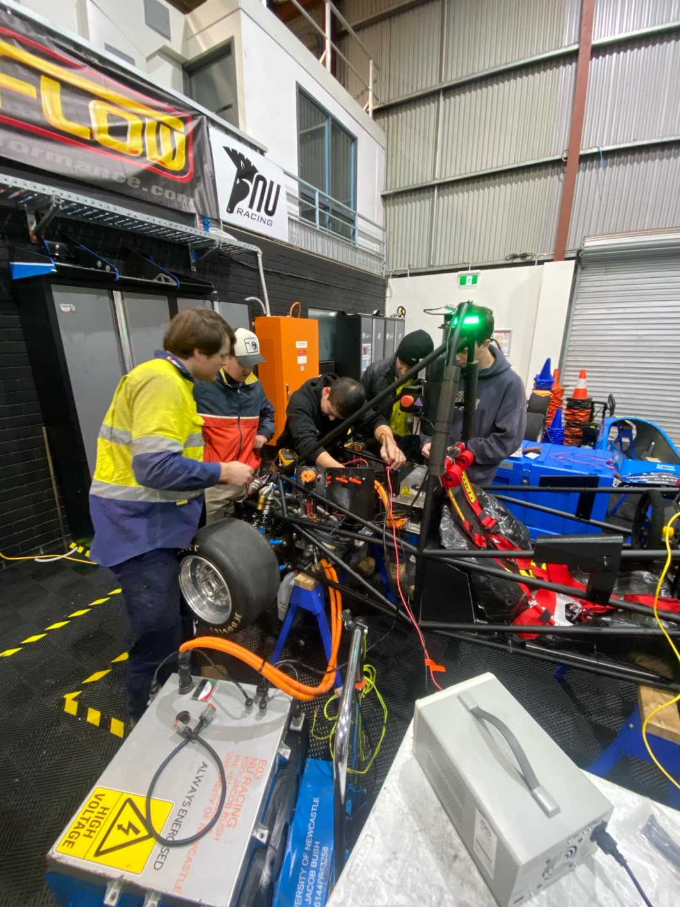

Figure 8 The Team Diagnosing the Voltage Drop

Once out, the team ran into issues with the BSPD’s current sensor. The new design of the HIP meant that there was noise subjected to the sensor signal, triggering the BSPD and shutting down the car. Details of the issue can be found in Jacob Lukes ENGG3200 Report. There were also issues with the HFL board and APPS PLAUS, the HFL required more testing and simulation, resulting in another version that worked, and APPS PLAUS was triggering due to Zener Diodes. These Zener Diodes were used as overvoltage protection for the Teensy, but due to their design, create non-linearity within the signals, removing them from the PEN fixed the issue.

Overall, the test was very successful, achieving the goal of a test with NU23, allowing issues to be found as soon as possible.

While not yet on NU24, being able to test the system as early as possible put the team in the best position, especially going into the last half of the year which is much busier for the MCHA team. The team really pulled together during this period and the team morale really picked up, as the MECH team was receiving their first parts, and the chassis was almost finished welding.

It is recommended to repeat this in future years, allowing for more driving of the new competition car and less problems in the busier half of the year.

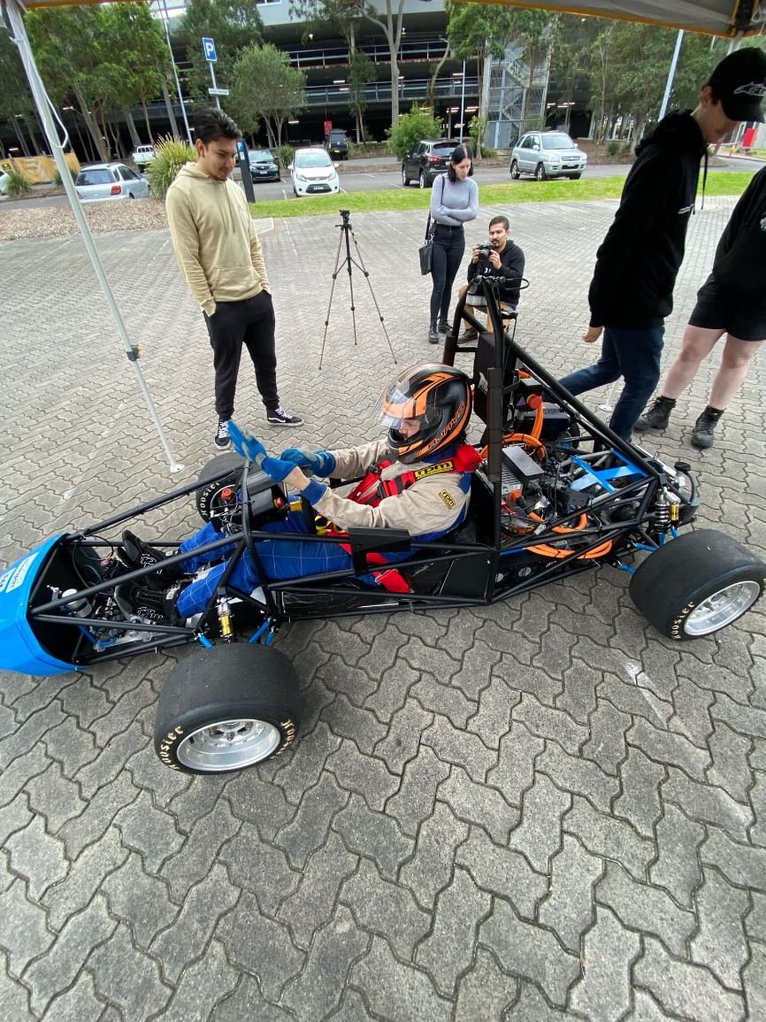

Figure 9 Tim Kerr getting ready to drive NU23 with the new LV System

Although the BSPD issue could not be fixed in the short term, the team prepared for the last Sydney Motorsport Park (SMSP) Test Day for NU23. The APPS PLAUS was fixed, and the issue had not been identified with the HFL.

The test day found an issue with the HIP and the Master Switches, halting a lot of driving. The master switches must be very carefully tightened to the pads of the HIP and tested with a Multimeter using continuity, too tight and the switch would fail. This was replaced on the stop by the team, and we continued testing.

This track day was very successful, highlighting the work the team needed to do during the downtime between the decommissioning of NU23 and the first drive of NU24.

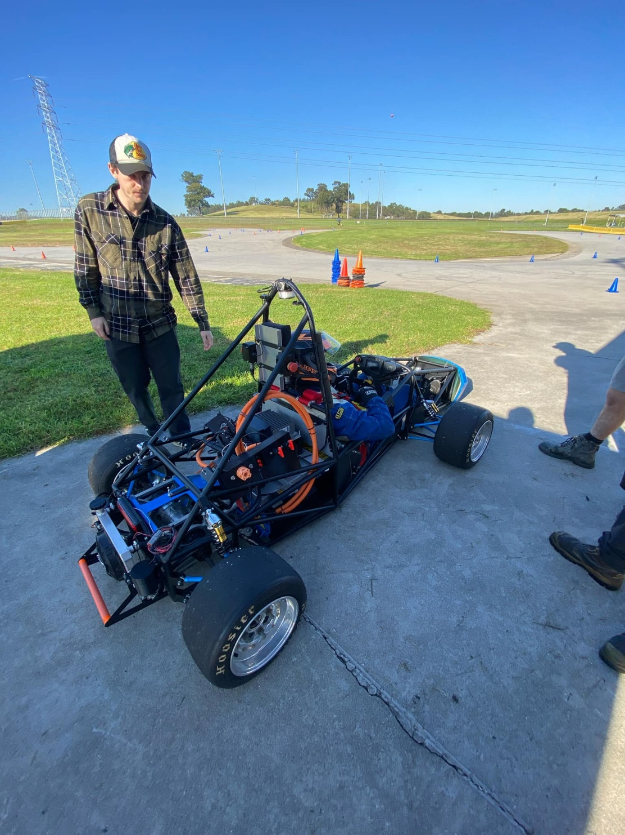

Figure 10 SMSP Test Day, NU23 Final Drive

# Cascadia CM200DZ Propulsion Inverter Failure

## Background and Inverter Failure

At the end of 2023, the team purchased a Cascadia CM200DZ inverter to replace the failed Bamocar units that were used that year. The new unit was only received a week before competition and integrated into NU23 in less than a day.

The preparation for this unit was short and the goal was to get it working rather than a deep understanding, thus Josh Hayward spent the first 2 months of 2024 reading and documenting all the information regarding this new inverter, as well as planning to set it up again slowly, following the instructions he had now researched. When paired with the EMRAX 188 and Cascadia’s designated settings for the unit, the inverter functioned correctly and without fault. For the documentation and anything related to the inverter, find Josh Hayward’s FYP Report.

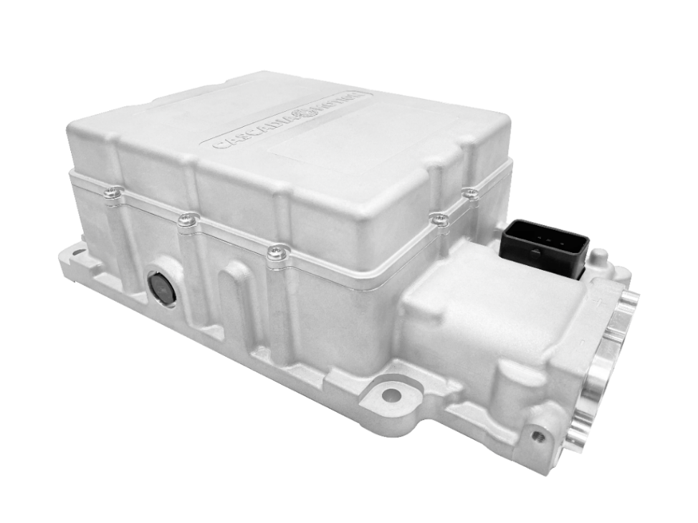

Figure 11 Cascadia CM200 Inverter

When adapting the inverter for NU24 and the EMRAX 228, the same process was completed using Cascadia’s setting for the motor. This was success and NU24 was driving for the first times without issues from the motor controller, running at a reduced torque settings due to doubt of the integrity of the power box, information on the power box can be found in Lachlan Fisher’s and Rishi Mathuria’s FYP Reports.

Before NU24’s second drive, NU24 was spun on the stands to ensure everything was working. During this an overcurrent fault on Phase A occurred. This issue was similar to the issues experienced with the old Bamocar although, the condition of the fault’s occurrence is not similar. After some initial troubleshooting and restarting the commissioning process for the inverter and motor, it was quickly released that the inverter was broken beyond NU Racing’s understanding to fix.

## Fault Finding and the Purchase of a New Inverter

Josh Hayward began receiving support online through Stealth EV, the supplier of the inverter, and attempted to receive support from Cascadia themselves. Both of these methods were unsuccessful as Stealth EV had been purchased by Hypercraft USA and had a very poor support team taking weeks to reply with very little useful information, and Cascadia, would not offer support for a unit purchased through another supplier.

While this was being investigated, the author contacted Cascadia directly for a brand-new inverter directly from the manufacturer. Purchasing through another third party was considered, but after the lack of support received from Stealth EV, it was clear that the new unit had to be purchased from Cascadia to unlock their support to ensure a replacement inverter does not have the same fate. Luckily NU Racing had a large amount of float remaining in the budget as well as saving money from completed projects or additional items which would only be purchased at the end of the year and so could afford to purchase the new inverter from Cascadia with the help of Dr Dylan Cuskelly, Mr Malcolm Sidney and Mr Tom Rabbit. The purchase also included new Phase Cables which were too short on NU24. The total cost of the new unit and cables was $13391.53.

During the conversations with Cascadia, they also recommended the DX unit rather than another DZ unit as its operation voltage range matches NU24’s better and will create a smoother driver. The units have the same weight, geometry and connectors and so would require no modification to NU24.

Table 2 CM200 Unit Comparison

|  |  |  |
| --- | --- | --- |
| Inverter | CM200DX | CM200DZ |
| Operating Voltage (V) | 50-480 | 20-840 |
| Motor current Peak (A) | 740 | 400 |
| power output peak (kw) | 225 | 225 |
| Motor continuous current (a) | 300 | 200 |

Once the purchase was made from Cascadia, they offered support on the set up of the new inverter, as well as some support on why the old inverter failed. After analysis of our log files, Cascadia found an issue with the motor stalling at low RPM due to the variable PWM frequency setting on the inverter, resulting in the loss of current regulation. It turns out Cascadia did not tune inverter settings for the EMRAX 228 MV very well, and such the variable PWM frequency setting was switched off.

Whilst the purchase of the new inverter was still being organised, Josh Hayward continued to get support from Hypercraft, eventually getting to a stage where they required diagnostic of the inverter. At this stage the author took over communication with Hypercraft so Josh Hayward’s focus could turn to the new inverter. The old, damaged inverter was sent to Hypercraft’s office in USA for diagnosis in November and has been followed up with several times, but no information has been relayed back to the team. The team should continue contacting Hypercraft for the diagnosis and repair of the unit, or if possible, a full refund.

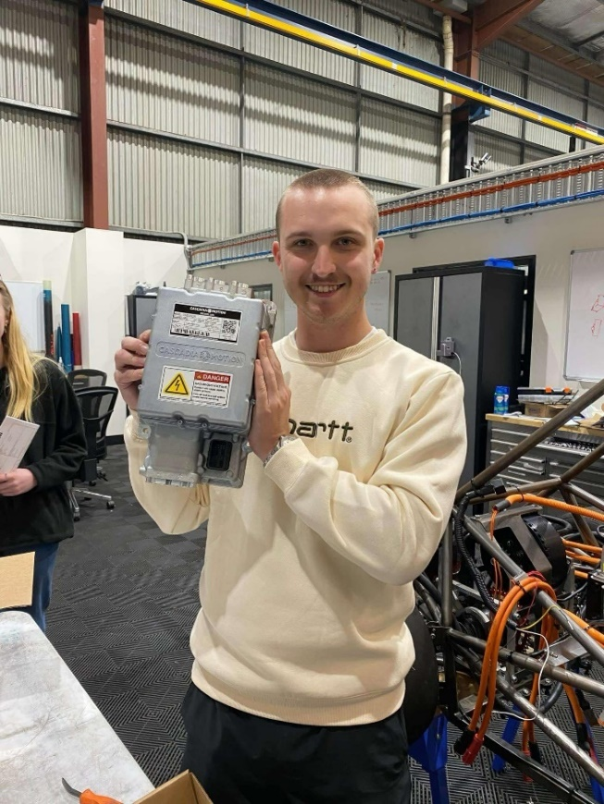

Figure 12 Josh Hayward receiving the new CM200DX

## CM200DX Integration and Noise Troubleshooting

Once the new inverter arrived at the university, it was slowly and carefully commissioned.

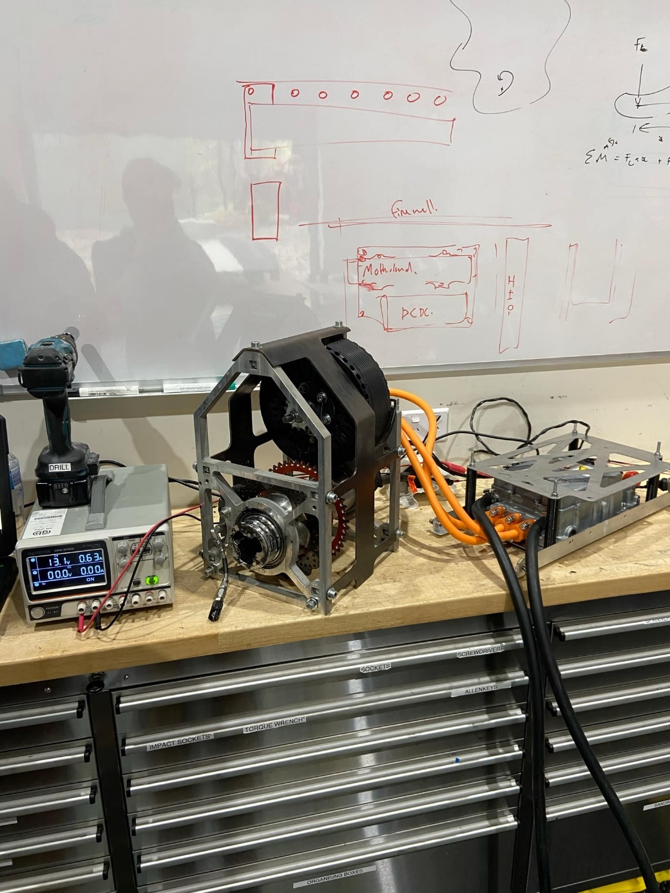

Figure 13 Resolver Tuning with CM200DX

It was set up and the resolver for the motor was tuned on the bench with the bare minimum connected to the components for simplicity. Once this was completed it was them installed back into the car.

All over components were connected and tested to ensure an optimum test. Once the car was fully operational excluding the inverter, the inverter was enabled. When the inverter was enabled, a large amount of noise was induced onto the cars CAN BUS network. Once all other systems were investigated, it was found that the inverter was indeed the source of the noise.

To properly identify what needed shielding, the MCHA system of the car was taken off the car and set up on the bench next to the car. Cascadia support was also contacted with no information as to why we were experiencing the new noise.

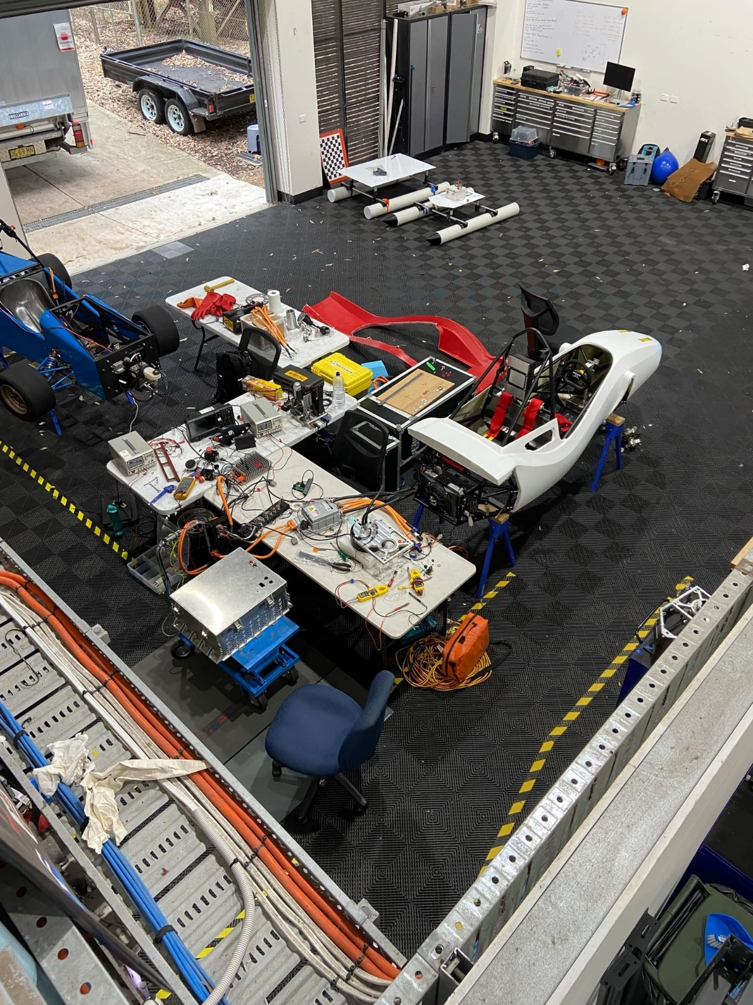

Figure 14 NU24 Bench Testing

Some other MCHA issues arose during the setup which had to be resolved before noise testing commenced. Each component was slowly added into the system to ensure the noise could be identified, resulting in the noise being generated in the MC-CEN loom.

The inverter had a dedicated isolated CAN GND pin which was used as the shielding ground for the CAN wires and the original wires were swapped to twisted shielded pair wire. Once installed the noise was greatly reduced, allowing for the car to stay in an enabled state, this was when another problem occurred with the inverter. During the troubleshooting of the inverter, firmware was reinstalled onto the inverter, but the wrong package was chosen, a package with did not support our motor. The team was not able to identify this issue without the help of a Cascadia support engineer on a zoom call early in the morning, who quickly realised we were in the wrong group of firmware. Once this was rectified and the motor resolver was retuned, the motor was able to spin on the bench without fault and with no noise on the CAN.

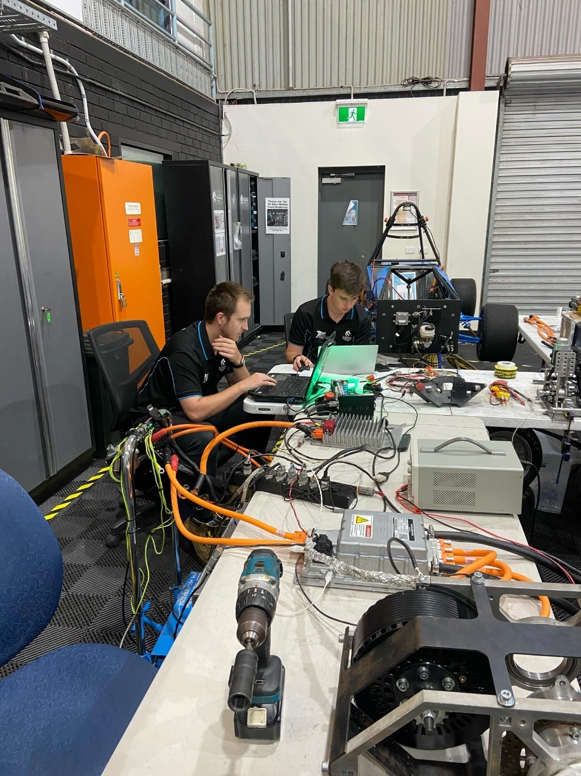

Figure 15 Early Morning Zoom call with Cascadia, Josh Hayward and Jacob Lukes

It is still unknown why the new inverter produced a large amount of noise, but it is recommended to shield all the CAN looms on the back half of the car in future years to prevent this issue for occurring.

The failure of the CM200DZ almost cost NU Racing the 2024 competition, taking two and a half months to fix and costing the team all its spare funds. This limited NU24 to only 5 weeks of testing before competition, halting the finding of issues until it was almost too late to fix them. It is highly recommended to either fix the damage inverter or to source a spare inverter for years to come, as they have a very long weight time and are still new components with limited testing even at the commercial level as we were not the only FSAEA team who suffered from inverter issues in 2024. It should also be noted that Cascadia is very helpful with their support but are situated in USA, and thus are operational in Australia in the early morning, communication can be slow. For more information about the technical aspects of this fault and recommendations, read Josh Hayward’s FYP report. Josh Hayward was the lead for this problem and stepped up to the challenge, doing an excellent job.

# Electrical System Form (ESF)

The ESF is a document needed for submission to FSAE using the Team Leaders submission page that is usually due in late August. It is a systems information form for SAE that outlines all the critical electrical systems on the car, this includes the tractive system, throttle, BSPD, shutdown circuit, the accumulator, Precharge and discharge.

This form needs to be filled out accurately, with no information missing, that is why it is the responsibility of the Mechatronic Department lead. Lucky SAE rarely change this document, so the previous year’s document is normally very helpful and will have majority of the information needed, with the rest requiring updates due to new designs.

Whilst completing this document, it is important to triple check everything submitted, as in 2024 the author found an issue with the compliance of the accumulator lining, this allowed time for the mechanical team to source a compliant material and change over the linings. Whilst reading the 2023 ESF the author also found an issue with the main fuse of the accumulator, something that the team needed to fix during the technical inspections at the 2023 competition.

From year to year all information should be checked and updated if now redundant or incorrect, this includes datasheets, values, item numbers, schematics and images. It is also likely that the current competition year’s form will not be released until close to the due date, so it is recommended to start in July once the car is running. There is no harm in starting early if time presents.

Although it is a critical document to submit, NU Racing has had little issues with the form.

It is recommended to submit this form at least a week early and with the Electrical System Advisor / Electrical System Officer Form (ESA/ESO Form) which is a single page form that only requires the information of some of the team members. Some of the team will require low voltage rescue training for this. A copy of the 2024 ESF is attached in the Appendix and can be found on Teams. The blank forms to fill out can be found on SAE’s website.

# Cost

Cost is worth 100 points in the FSAE-A competition and is comprised of a cost report of the entire car (prior to competition), a cost scenario which normally focuses on an aspect of the report (at competition), and a cost event where a component on the car gets costed on the spot (at competition).

The cost report is the largest submission NU Racing makes in a competition year, detailing how everyone component on the car is made and assembled together, using cost values, components and multipliers defined by SAE. This an excel document that has specific rules and processes defined by SAE as well as the Cost leader within the team. This document is very MECH heavy, going into explicit details of mechanical systems but mechatronic systems are present including wiring diagrams.

It is recommended that a MECH on the team take the lead of this report, getting accustomed to the procedures and is able to teach others in the team. A MCHA lead should also be chosen as how things are done is complicated and someone is needed to check over everything before submission. It is recommended that the department leaders are not the Cost leaders, although involvement in the report is required.

This section will detail the MCHA systems in the cost report, general information about the cost report and the MECH system can be found in Lachlan Fisher’s report. Involvement in the cost scenario and event will also be documented.

## The Cost Report

The cost report should be started as early as possible, ideally as the team finishes a project, this method will reduce the main load of the cost report during submission time which traditional for NU Racing, as been a massive crunch period. The report submission date is normally early October for the report as must be submitted by the Team Leader on the submission portal.

In 2024, the detail of the electronic components in the cost report increased, adding accuracy to PCB assembly and increasing the MCHA load in the report with its complexity.

The MCHA load in the cost report includes:

* The Electrical System category (PCBs, looms, enclosures, brake light, DCDC and all other components which are LV)
* The MCHA components in the Accumulator in the Tractive Path and Drivetrain section (PCBs, looms, BMS, cells, etc.)
* Motor and Motor Controller in Tractive Path and Drivetrain.
* Autonomous System (for when the NU Racing competition vehicle is AV)

Before starting work on the cost report, the MCHA cost lead must complete the Bill of Materials (BOM) with the MECH lead, this will list every component which needs to be costed, allowing for others to start helping out if they are familiar with costing components. It is ideal if senior members like the MCHA department lead checks over this BOM.

Ideally by now, the procedures of creating part and assembly sheets are created allowing for the team to get familiar with the process. All team members should be assigned to their respective system in the report and can start working. The most complex part of the report is the mass amount of materials, processing, tooling and fasteners to select from. It is highly likely that majority of the sheets will have to be redone or adjusted due to incorrect materials or processes being selected or steps being missed.

In 2023 the electrical systems were not required to be very accurate and so could not be used as a guide for 2024, hopefully there will be no major changes in 2025 so the 2024 can be used as a useful guide. The 2024 document is found on teams and the sheets completed and checked by the author are found in the Cost Report in the Appendix.

### PCB

The process in the cost report is similar to real life, and such existing experience of PCB manufacture is recommended for members doing these components. The materials should include all components on the PCBs, including simple components like resistors, capacitors and fuses, ICs, connectors, microcontrollers, the PCB itself and conformal coating.

It is recommended to look at all the PCBs in the 2024 document when starting 2025 to understand what components fit in what material category and how to fill out the unit information for the material. The materials each have a description of what fits in where and these should be read to ensure that everything is done correctly and accurately. An accurate description of each item should be included for each material, so it is as clear as possible for SAE.

The processes need to be taken extremely literally, this includes flipping the board over to access the other side, solder paste for SMD parts and individually soldering through hole parts. As NU Racing uses DT connectors which are fastened onto the board too, a washer has to be manually placed on a screw before being hand started and then screwed by screwdriver into place. Even programming the Teensy 4.0 and applying the conformal coating needs to be individual lines in the process section.

Fasteners are the same throughout the report so consult a MECH or assistance but Tooling for PCBs in specific. A PCB stencil and PCB component position jig must be added with a Present Value Factor (PVF) of 3000 or whatever is deemed the PVF size for the competition year.

### Looms

Looms are fairly repetitive and simple in the cost report but how repetitions and quantities are done can be confusing. It is important that consistency is present in the report and much I recommended that all looms are completed the same.

Wires are split up into what they are used for, so HV wire is different to LV wire, and the amount of wire should go the length of the loom, this is what goes in the unit section, and then how many of each type of wire is in the loom as the quantity.

Each boot, heat shrink, and conduit also need to be added in the materials list and be entered the same as wires. The connectors also need to be chosen correctly, with different connectors fitting in different categories, again study the 2024 report as well as the materials list. Eye crimps and the like count as connectors, and individual pins for like DT connectors are included within the connector rather than a separate material

The processes include, cutting and stripping the wire, sliding on heat shrink or conduit, assembling boots, crimping the pins of the connector before inserting into the connector and shrinking the heat shrink. Again, this process matches real life and such someone familiar with the looms should complete these parts.

There is no tooling required for looms.

### Assemblies

Assemblies are similar to the MECH systems and are extremely repetitive. Assemblies are just processes and fasteners and every step is extremely literal. Each washer much be assembled onto each bolt, each nut needs to be hand started and reaction tools are needed. The quantity and multipliers need to be carefully thought about, and it is recommended to use the quantity as the amount needed for the individual part, and the multiplier for the amount of that individual part. A description of each step is needed too.

This is normally simple but for components like the HIP, the assembly is extremely complex, as such it is useful for the designer to produce these in the report. If not, it should be pulled apart by a knowledgeable team member and put back together while filling out the sheet.

### All Other Components

Most of the other components like main fuses, switches, sensors, and off the shelf components all have a specific material and such do not need to be custom made. If a component does not fit any material on the list, SAE can be contacted, and it can be requested to added to the material list, otherwise it will have to be custom made.

Enclosures are made using the weight of filament used and then the Rapid Prototype- Plastic process to be made. Threaded inserts are also just fasteners which are interference fit.

Common sense and an understanding of the current rules surrounding the cost report are needed to ensure the best result.

## The Cost Scenario:

The Scenario is supplied by SAE a month before competition but traditionally has been completed by NU Racing whilst at accommodation in Melbourne which is not the best practise but has been successful. Usually, multiple scenarios are given by SAE to choose, and the team must present their solution to their choice scenario at competition during Cost.

The chosen scenario in 2024 was to take the team’s cost report and reduce the cost of the vehicle by 5% without reducing performance by more than 1%. Lachlan Fisher and the Author were the team members involved, with Lachlan taking the lead. The amount the team needed to save was $2214.81.

First the serviceability items were removed by Lachlan, these were the dry disconnects in the brake lines and the quick release latches on the body kit and replaced these with hardlines and bolts. Attention then turned to the Motor controller and motor, as they are costed by continuous power, and another are capable of producing more power than the competition allows. It was found by the author that the EMRAX 208 motor was capable of producing the same amount of power and torque with modified gearing as the EMRAX 228 and the current gearing. Both members then costed the smaller 208 and appropriate gearing saving $1899.60. Combined with the $273 saving from the dry disconnects and the $584.72 from the quick latches, the team managed to save $2757.32, $542.52 more than what was required, with no performance loss.

The performance was verified by Josh Hayward’s acceleration simulation which models the motor’s output with a simplified model of NU24. It was actually found that the 208 was fractionally faster due to the weight savings, increasing performance by 1% rather than decreasing it.

The team was very happy with the performance of the Cost Scenario, leaving the judges with no questions. The slides of The Cost Scenario Presentation are attached in Appendix.

## The Cost Event

This event requires the team to quickly cost a component on the team in front of the judges. It is highly likely that the component will be a mechanical component, (it has been the steering system for the last two years) but there is a change a mechatronic component is chosen, thus both the MECH and MCHA cost report leads should be at this event.

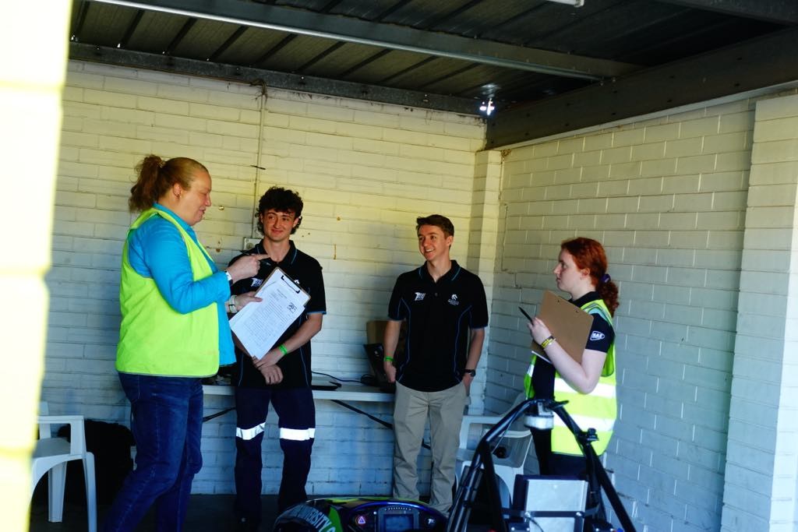

Figure 16 Lachlan Fisher and the Author during Cost at FSAE-A 2024

# NU24 Testing

The 2024 NU Racing team had the first drive of NU24 on the 13th of July, which was the earliest that a competition car was running, which is a massive credit to the prior teams and the current teams hard work and dedication. This set the second half of the year up the best it possible could, and the team needed as much time as possible with the motor controller issue descripted in the Cascadia CM200DZ Propulsion Inverter Failure section, stopping all driving after the first shakedown of NU24.

Once this issue was resolved and some very long nights, the car made it to the track for the first time in two and a half months on the 28th of October at SMSP.

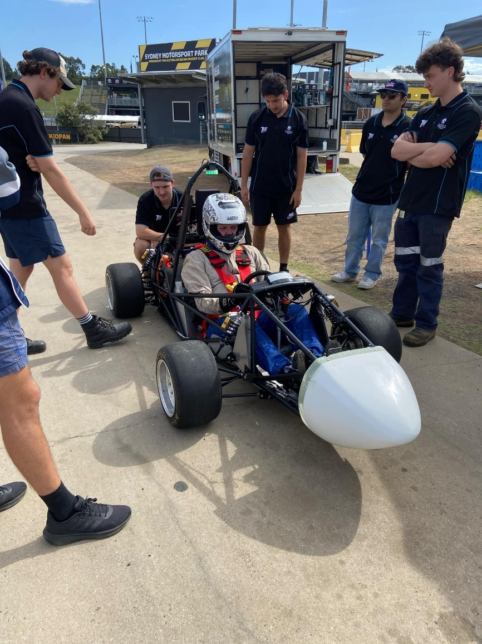

Figure 17 NU24 at First SMSP Track Day

This first track day highlighted a lot of issues with the car, both MECH and MCHA.

* The motor could not be run near its maximum torque limit due to the motor plate bending and the motor hitting the chain guard. The torque limit was run between 140 Nm and 160 Nm rather than having the full range of 230 Nm. A new Powerbox had to be designed.
* The 2023 endurance AMS fault finally was repeated, having a poor cell performance on Cell 7 and 8. These cells were replaced with new cells which the team had spare.
* The LVD’s fan power Mosfet desoldered itself from the board. This is due to the heat generated at the high current and such needed to be replaced by a higher capacity automotive relay. This issue was an easy issue to diagnose and fix, and its failure highlighted the improved cooling of the aluminium accumulator container compared to the painted steel container. More details can be found in Daniel Iverson’s FYP report.
* The HFL board had a few problems with signal Mosfets and the soft starter. To fix this issue a new version of the board was made, and the circuitry was simplified, as well as a resistor on the soft starter was changed. This board had several issues during the cars down time too.
* The DEN and MC looms were incorrectly plugged in, damaging the BSPD functionality on the BSPD board and PEN. This was quickly diagnosed and fixed back at TA, the track day continued by bypassing the BPSD. To avoid this happening in the future, keyed connectors should be used.
* The TSAL enclosure failed at the very end, and such was fixed with super glue back in TA.
* More problems with the master switches arose, this time the GLVMS failed momentarily but did not need to be replaced as it started functioning again. It is recommended to investigate different master switches in the future.
* The MC required a power cycle after every drive due to an issue with the enable, this was fixed by Josh Hayward, and information can be found in his report.
* Due to the capacity of the motor, at the maximum torque limits, the motor could draw more current than what was chemically allowed by the cells. To fix this charge and discharge current limits (CCL and DCL) needed to be configured in the BMS and read by the MC. This is also completed by Josh Hayward and can be found in his report.

While all these issues were found. The track day was a big relief for the team. To see NU24 running again faster than it ever had was a massive reward for the team after all the last nights and hard work.

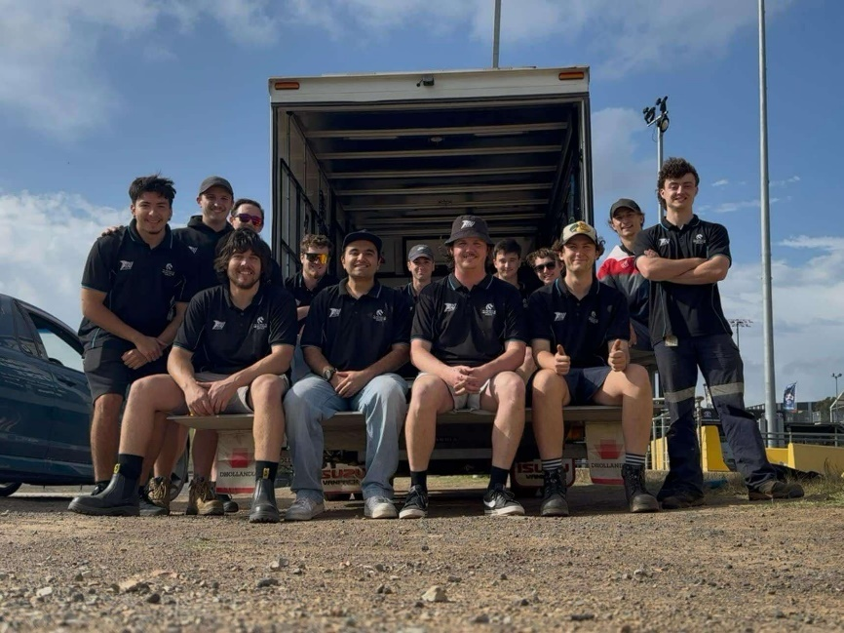

Figure 18 SMSP Track Day Crew

The team had a week to work on these issues before NU Racing’s first day and night track day at SMSP. The accumulator lining was also swapped to FR4 during the week.

During the day the team was on the skid circuit and encountered another AMS fault in the morning. This was a different issue than what occurred on the first track day, with cells 48 displaying a high resistance. After inspecting the BMS logs, it was found that cells 48, 97, and 107 were all damage and had high resistance, likely due to running without current limits on the first track day. Due to the large day planned, member of the team was heading to SMSP later for the night shift, these members were able to bring spare cells so the team could open the accumulator and replace the damaged cells in the truck. Once this was done, the team charged the accumulator and moved to the skid pad.

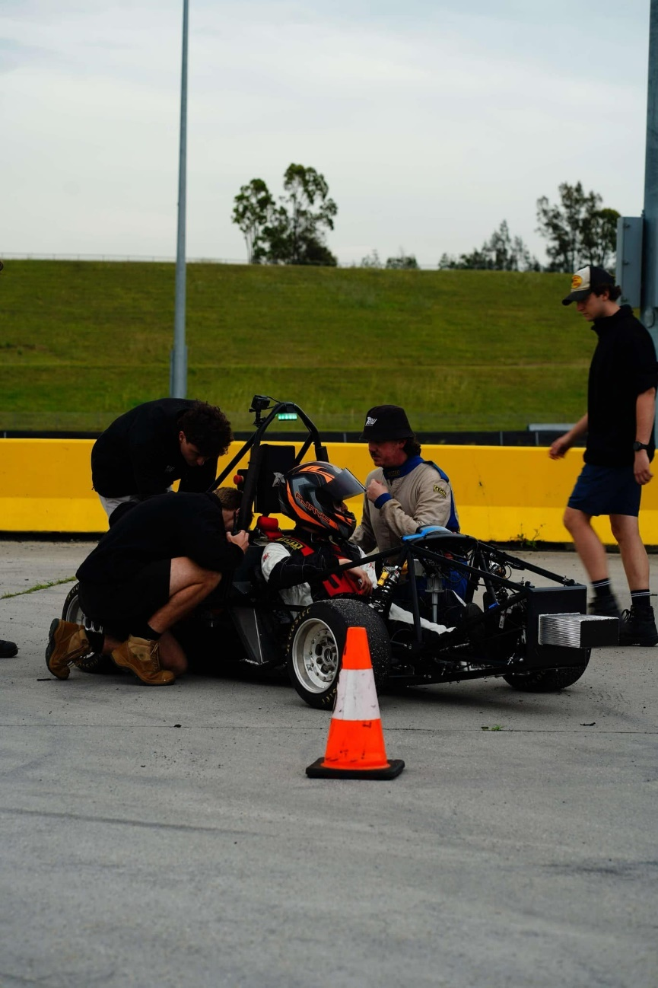

Figure 19 Testing on SMSP Skid Circuit

Whilst on the Skidpad it was found that the BSPD wasn’t functioning correctly from the damage it received last track day, but this did not require major attention at the track. The car did not have any more AMS faults during the day or night, and we managed to do two full charges before heading home. The only new issue was the LV power on the HIP PCB.

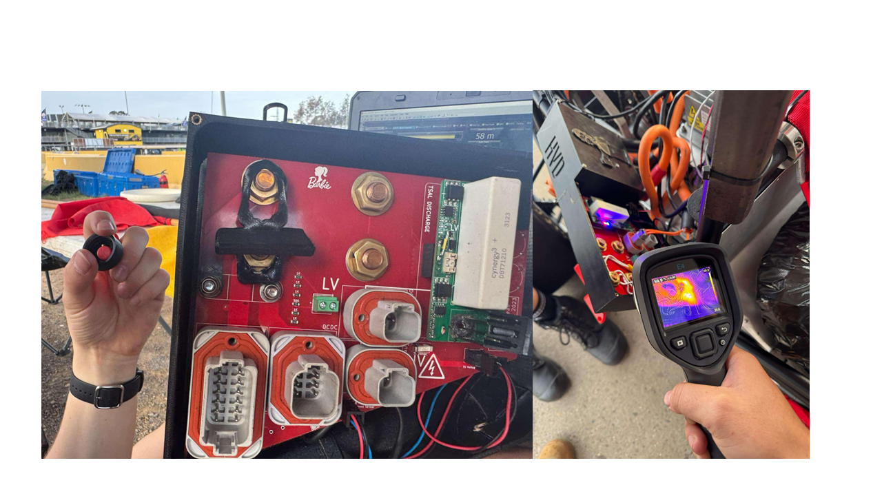

Figure 20 High Current Trace Damage on HIP PCB

One of the bolts used to mount the main fuse was galvanized, and created resistance in the circuit, heating up and damaging the power traces. The traces were undersized as well, creating a large amount of heat, melting the positive locking mechanism used to retain the master switch nuts. To patch fix this issue can keep driving, wires were added to support the trace in each section and the bolts were replaced with zinc coated bolts. A new HIP PCB was needed to permanently fix this issue, with enlarged copper traces and pad size for the main fuse and switches, the new PCB was also ordered with 2oz copper, rather than the default 1oz.

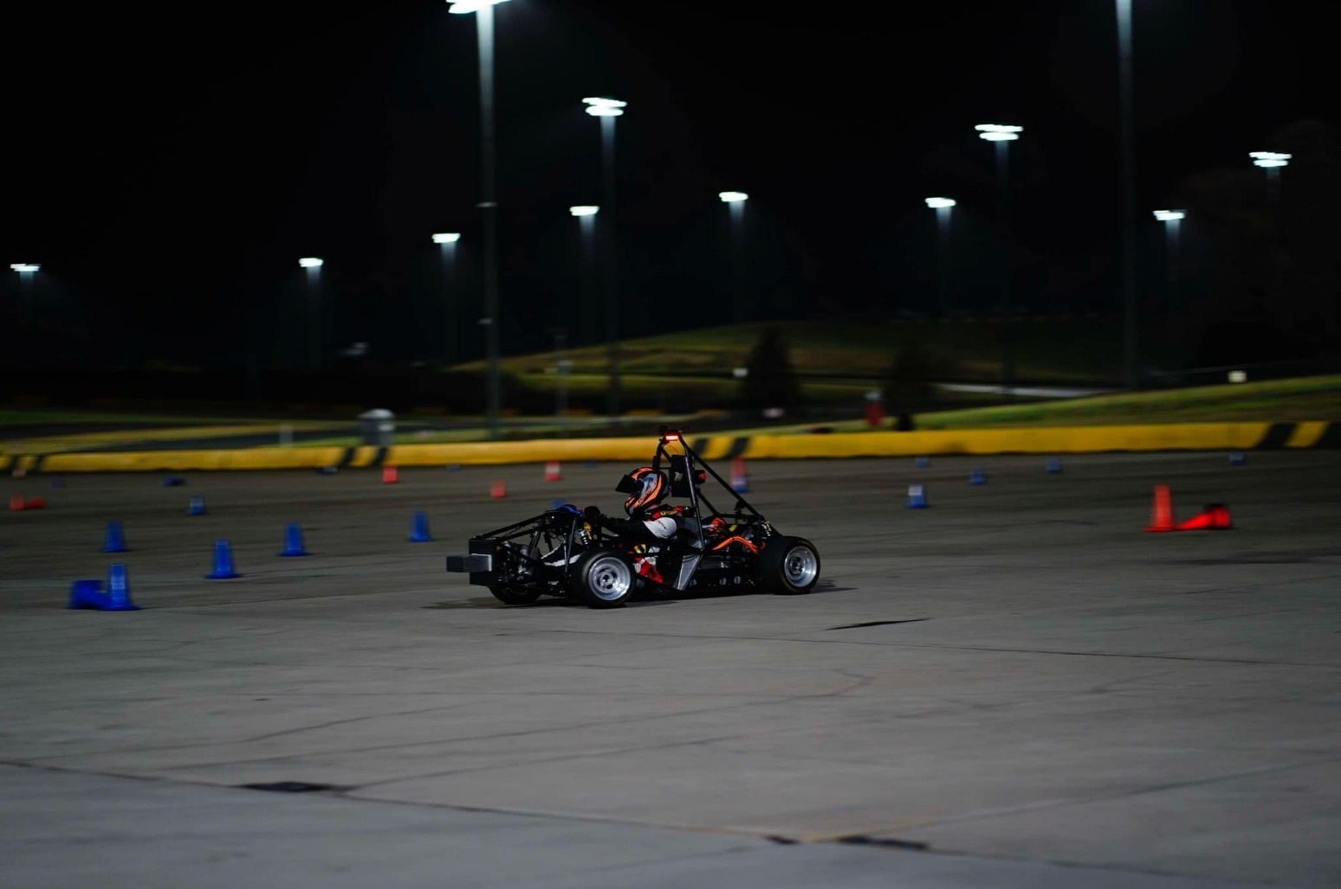

Figure 21 NU24 Driving Under the Lights

Once this HIP was patch fixed, the team got back out and continued testing, finishing the night with no future issues. This track day was the longest track day that the team has ever done but was still very successful, collecting a large amount of data. It was also found that the right side of the car near the HIP was very noisy, it is recommended that this is investigated and fixed in the future.

From this point, NU Racing had two track days a week in Sydney as competition was less than a month away. The new HIP PCB was ordered, the BSPD/PEN was still having some issues, and we couldn’t run the car at its torque limit due to the weak Powerbox, all issues which had clear fixes.

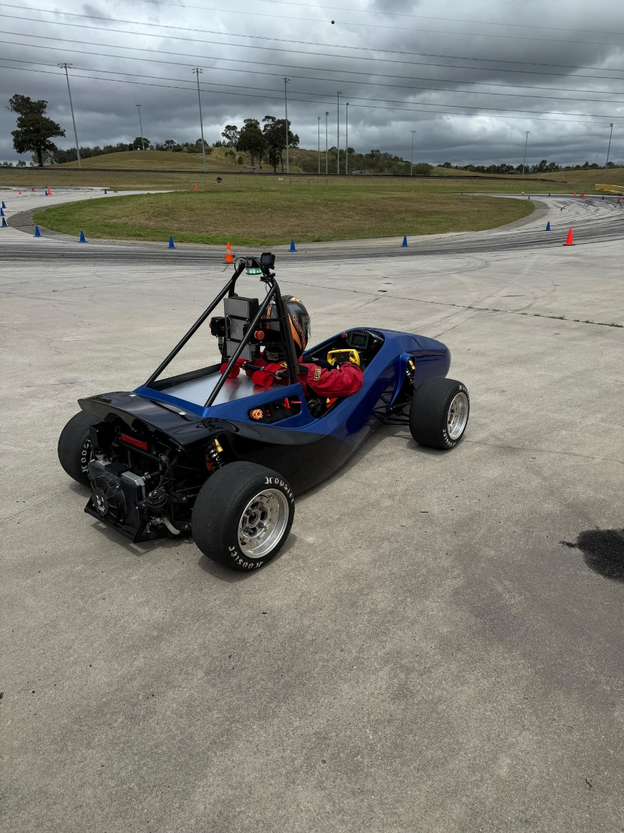

Figure 22 Heading out to Test Spring Rates

The next track day was even more successful, regenerative braking was enabled and used during an endurance run, data and more testing on regen can be found in Josh Hayward’s report. The only issue encountered was the BSPD which related to issues APPS TRAIL as well, making the car challenging to drive to unexperienced FSAE drivers. This was happening due to noise on the pressure sensors, making the BSPD flicker, stopping current draw when accelerating, due to the PEN becoming damaged when the CEN was plugged in incorrectly. To fix this issue, Jacob Lukes soldered a capacitor onto the input circuit of each pressure signal, smoothing the noise and fixing all the issues surrounding the BSPD. The brake sensor looms were also remade as they were quite damaged.

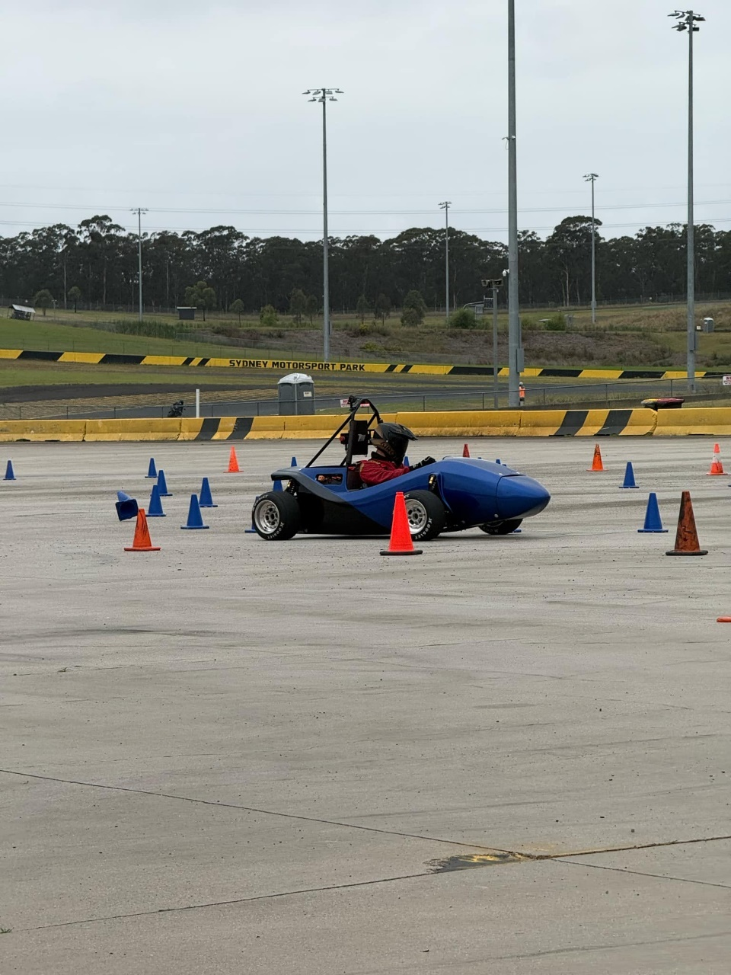

Figure 23 Skidpad Training at SMSP

Due to the short amount of time left till competition, the team did not want to change anything that did not need to be changed, only damaged or faulty components were to be altered. Thus, majority of the time, the car was run with minimal changes to systems and the focus was so train drivers for their events.

On an SMSP track day on the 14th of November, the AMS fault on cells 7 and 8 returned, which was alarming as these cells had already been replaced, the accumulator was opened, and the voltage taps on those cells were inspected, as well as the CANaMON. There was nothing visually wrong other than the trace on the PCB for those cells were black but had low resistance and work 99% of the time. The accumulator was put back together, and the fault was cleared from the BMS. The car worked for the rest of the day with no issues.

The next track day on the 18th of November was the first track day with no MCHA issues, in fact functionality was added to the PEN code, implementing a power limit now that the motor has the capacity to go over 80 kW. The AMS issue did not occur.

A wheel bearing failure meant that the car did not drive for a week but it was appley timed as our chassis was deemed non-compliant in the SES. The fix was welding in 4 new members so the downtime of the car was used for that. The car was stripped so it could be welded so the opportuinity was taken to currectly size, heat shrink and boot every loom on the car.

Once reassembled and with a compliant chassis and new power box, the car was ran again in SMSP on the 21st. The AMS fault occurred again, and such new CANaMON PCBs had to be ordered with the hope that they would arrive before competition. The fault was cleared and the car continued driving. This day went well but it was highlighted that the Teensy on the PEN needed to be hot glued down and during the reassembly of the car it got knocked and came loose while driving, lucky the cars BSPD kicked in and turned HV off. This showed the rest why we have safe practises while testing, as well as trained drivers and safety systems on the car. This was the first drive with the strengthen power box too and such the the torque limits were tested but the motor plate was still bending. The maximum torque request without motor bending was 180 Nm, and such seemed to be close to the traction limit on this surface.

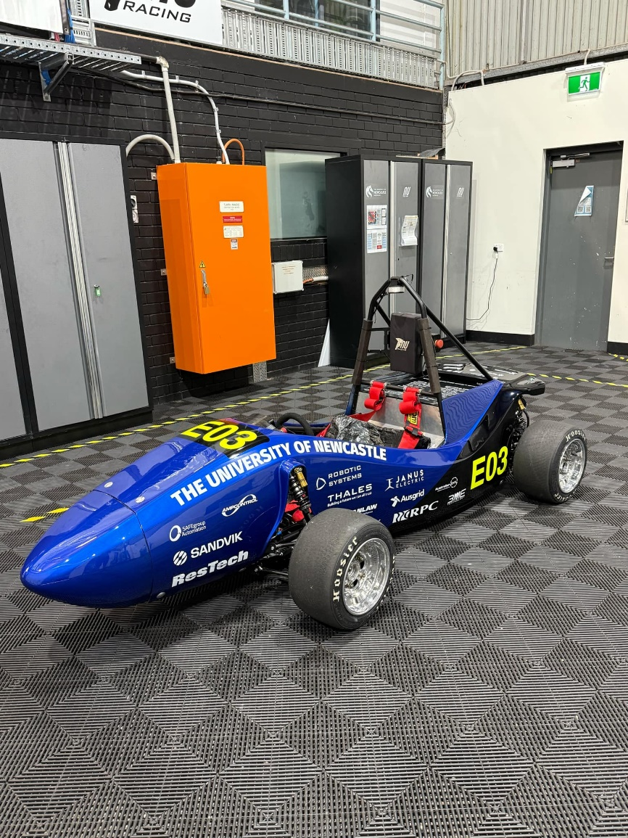

Figure 24 NU24 Presented at the NU Teams Expo

NU24 was then presented at the NU Teams Expo as our competition platform, even with the inconsistent AMS issue, the team was content where the car was performance wise, 2 weeks out from competition.

Our last SMSP track day was on the 25th of November. The new HIP had arrived and was ready to be put on the car while charging although this swap was not easy. During the assembly of the new enclosure the HVD interlock connector and discharge resistor was damaged, the resistor being the most complex of the two. The interlock was an easy fix and was replaced with the one used in AVONE as there were not any spare, but the resistor required some questionable methods to reattach the resistor legs. After testing, the quick fix as sufficient for the day, allowing us to test the new HIP and continue driving, whilst there still was some heat generated, it was much better than the original HIP and low enough to be used without issues. The day seemed to be on track to end well until the DCDC failed.

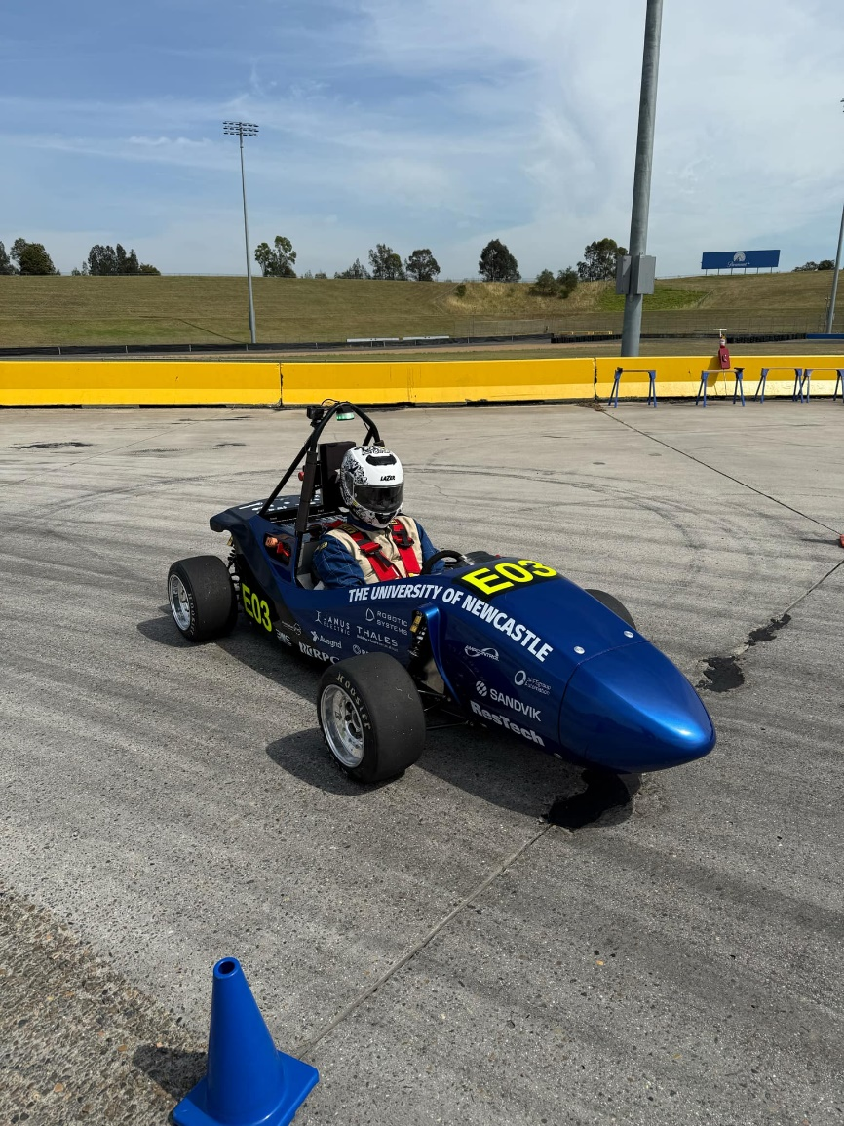

Figure 25 NU24 Last SMSP Track Day before Competition

The DCDC had no signs of failure, still enabled correctly with both CAN and the 12V enable pin, displayed over CAN that it was enabled and that it had no faults but it simple would not output current. The DCDC is a component which the team did not keep a spare of being an off the shelf part that is robust and simple to interface with.

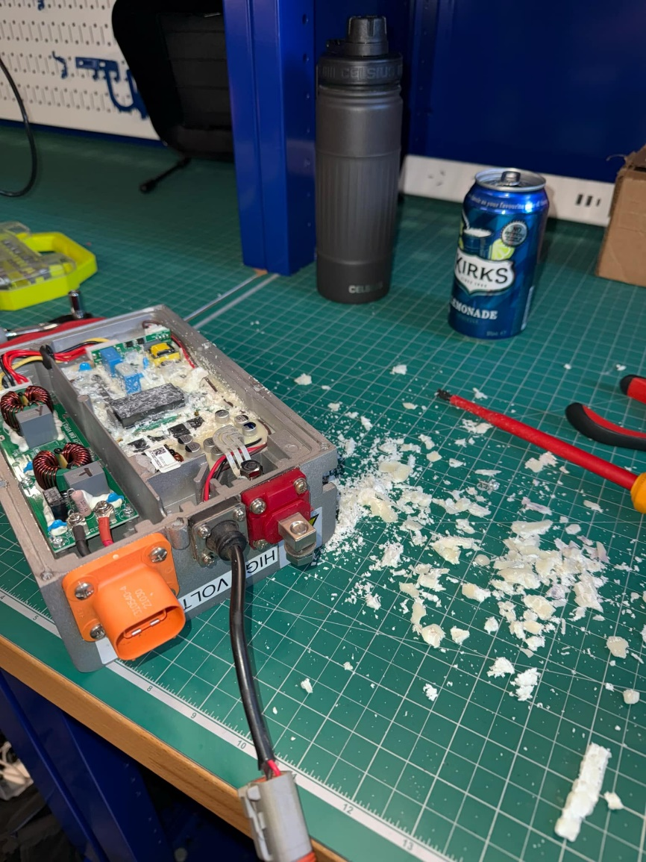

Figure 26 Fault Finding the broken DCDC without Success

With only 1 week to competition, a new DCDC had to be sourced and delivered. A replacement was coursed from EV Shop EU and expressed delivered to TA on Friday before being commissioned, the unit was slightly different but had the same mounting holes and an increased current capacity. Nothing had to be changed for the unit apart from the 12V connections, shortening the positive to a reasonable length before bolting the eyelet terminals together and the GND was now any point on the enclosure. The new unit worked immediately and without issue. Sadly, we had to cancel the Thursday track day planned due to the DCDC not arriving in time.

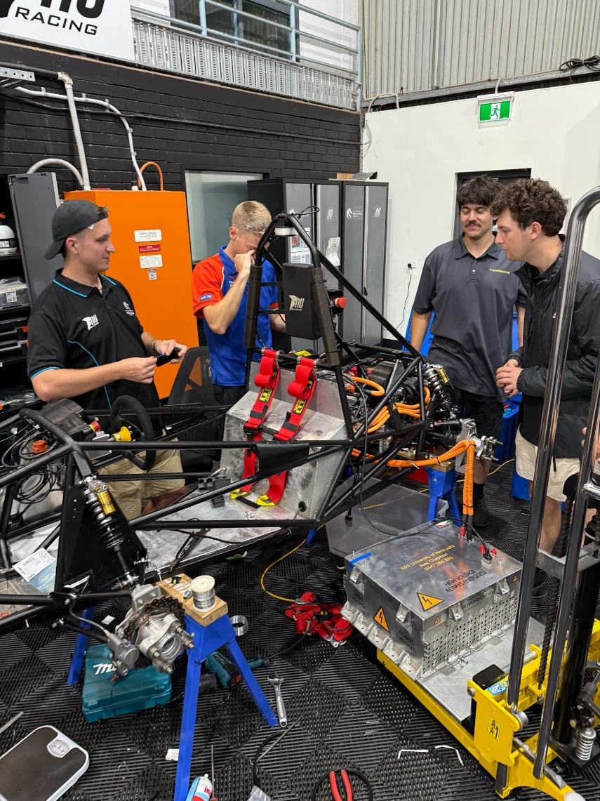

Figure 27 New DCDC Commission

As a precaution the author calculated the size LV battery needed to run the car for an endurance and NU Marine luckily had a spare we could use if worse came to worse. A second DCDC was also ordered as a spare from EV West in America, arriving on Wednesday for Mr Malcolm Sidney to bring down to competition in a packed suitcase.

On the Saturday before leading for competition the car was ran momentarily, the motor was spinning in the opposite direction and the chain was skipping. These issues had quick fixes but that meant the car only ran a couple hundred metres. NU24 was taken back to TA and the PCB enclosures were disassembled to hot glue gun the PEN Teensy and potentiometers to ensure they did not move, as well as conformal coat the PCBs and seal the enclosures with silicone for the rain test.

After a resolver recalibration, reassembly of the enclosures, changing the chain and drive sprockets and the repair of a GND pin on the Precharge board in the accumulator, the car was ready to be check at a final drive in the ICT carpark at the university.

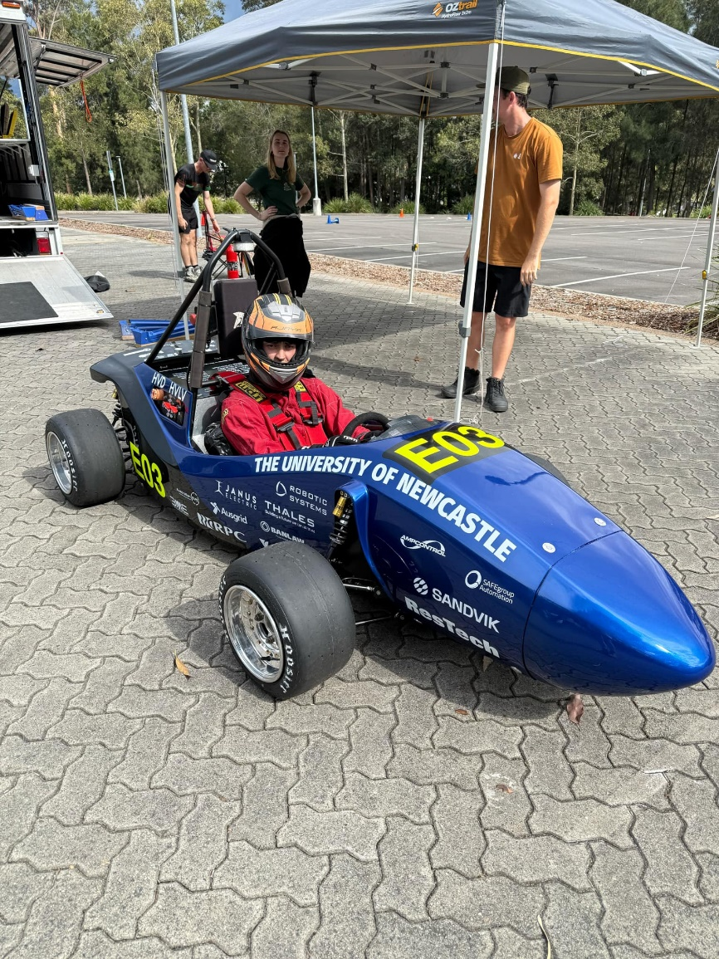

Figure 28 NU24 Final Carpark Drive

Half a charge was completed due to weather and time restrictions, but all systems were operational, and the car was finally ready for competition.

2024 was extremely compromised by the inverter fault, condensing the time to find and fix all the other issues on the car. The team worked so incredibly hard to get to competition and should be incredible proud regardless of the result. Whilst its reliability was still questionable, its performance was impressive, and team was ready to take on the other teams. With all drivers practised and ready.

Even with the delays, NU24 still did 350 km of testing, which is only 70 km less than NU23 did with many more track days. Overall, the track days were run very efficiently, and the team got the most out of everyone, even with the faults. The testing period of the car, while short, was very successful, although there is a lot to improve on in future to avoid the issues and delays the 2024 team faced.

Some of these things are:

* Ensuring the team has spares of every major component on the car. This alone would have allowed the team to test for another 2 months as well as reduced the stress in the final week before competition. This not only increases the team’s testing ability but will also reduce stress in every team member. Ensure a proper diagnosis of issues in undertaken before swapping over damaged components.
* More testing or at least driving should be done with the previous competition car, NU23 was only driven three times in the first half of 2024 before it’s decommission. It is a perfect test bed for any changes that can be made early in the year or at the very least, is the best way for a new team to select potential drivers for the year. In 2024 only two members had previously driven, and such were the test drivers, but this left little room for when these members could not make testing events. More track days early on will let the team become comfortable with the operation of the day and will make the important track days in the back half of the year more efficient.
* A strict record of each change to the car should be kept. This change log should have a descriptive short comment attached to an in-depth long comment of the change and its success or failure. This document should be accessed by everyone, so every team member is up to date with the car as well as having a shared document for reference during report time.
* A condition log should also be made and documented such that every team member can understand the state at which the car is in during assembly and reassembly. It is not uncommon for components to be taken off the car between track days for repair, upgrades, setting changes or inspection and having a document which states the condition of the car will remove the risk of damaging a component or wasting a team members time thinking a system can be tested when it is currently affected by another. This document could also state whether or not a set list of functions is operational e.g. LV is operational, but HV is not operational.

These changes will ensure a much smoother year in 2025 and beyond.

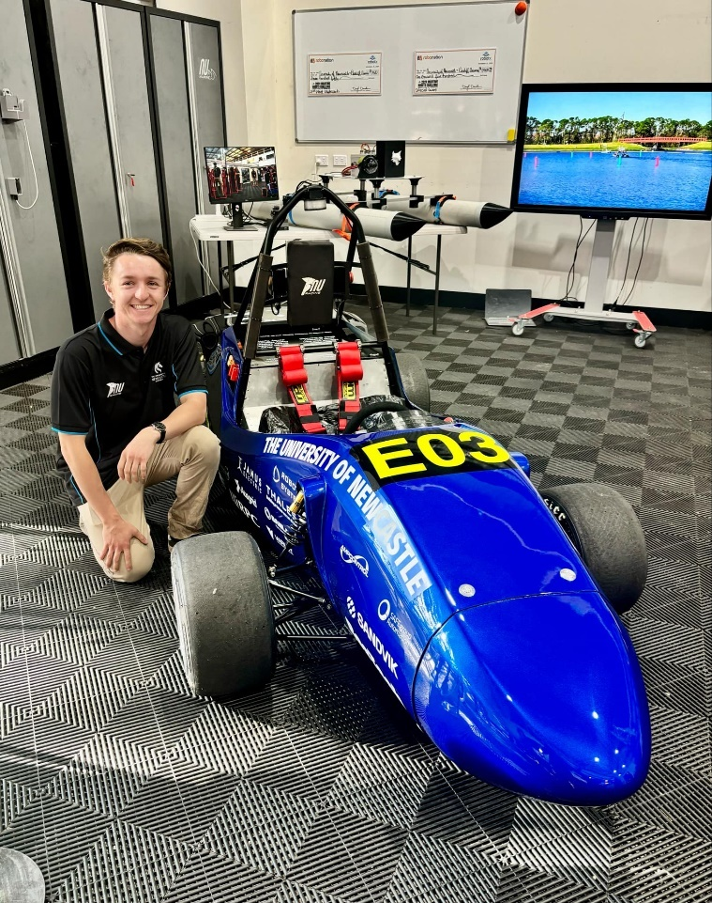

Figure 29 The Author Pictured with NU24 at the NU Teams Expo

# Technical Inspection

## Overview

Technical Inspection (TI) is the gateway to the Dynamic Events at competition, putting the team through rigorous tests to ensure the car is ready to race. These inspections ensure the vehicle has quality made structures and has all the necessary safety systems and design requirements dictated by SAE in the rules, although not every rule is tested. There can be some disparity between the rules and the technical inspection requirements, so it is critical that all requirements are met in both documents to ensure an easy technical inspection at competition.

Helena De Gruchy did a deep dive on all the inspections in 2023, covering all inspections from the 2023 competition, as well as all important information regarding the inspections, this can be found in her ENGG4200 Report. Only the mechatronic aspects of the inspections will be covered by this section as in 2024, the inspections were separated into the separate departments. Both the MECH and MCHA department leads took the lead on their technical inspection sections. Information regarding the mechanical technical inspections can be found in Lachlan Fisher’s FYP Report. In future, it is recommended that the department leads are not the leads in TI but should be highly involved.

The most effective way for TIs to run is the leads assess what is still needed to pass inspects and then inform the department leads who will double check and then delegate work to the team. Once the work is completed it is given to the TI leads to format and reassess until all TIs are passed.

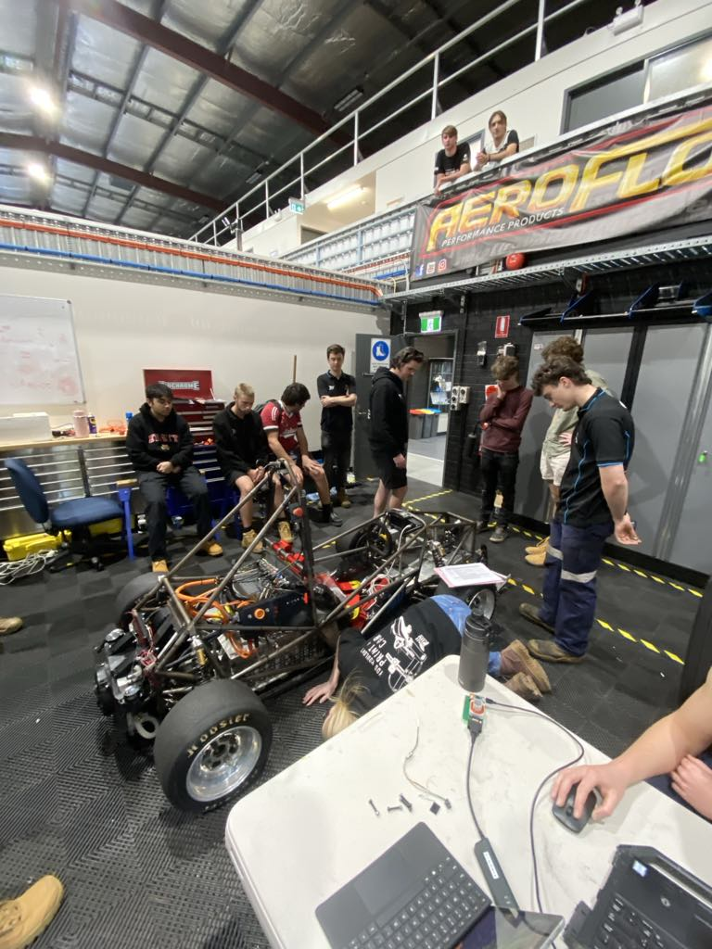

Figure 30 Team Conducting First Technical Inspection in August

The most important aspect of technical inspections is rehearsal. It is vital that all the members in TIs are practised and ready to tackle the hardest of questions from scrutineers, and part of this preparation includes proving all the components meet the requires through datasheets, samples, images and videos. The majority of the work the TI leads will complete is the collection of all the evidence and formatting it in such a way that allows the inspection to flow from one point to the next. NU Racing has used a folder with all these documents sorted in order for the past years with great success. To pair with the documents, the TI’s document from FSAE was also adapted with comments to reference what is needed at each inspection, what to do in each step and what reference documents to use, this is called The MCHA Technical Inspection Bible: and is attached in the Appendix.

Everything important to TI should be stored in the TI box and all documents can be found on Teams.

In the build up to competition, the tech teams should do mock TIs with increasing regularity, the earlier this start, the better. Ideally the car is in the best state it could be at the time when completed and should be taken seriously, with the first run throughs being more relax but still fully aware of what passes and what doesn’t. These also help identify non-compliant systems on the car, allowing for reification by the team, but the TIs should already be familiar as they should be checked during system design. In 2024, TIs did not happen early enough due to the inverter issue, and such the car was not compliant until packing day for competition.

All technical inspections are to be completed in one hour at competition and should be choreographed that it is possible. At every inspection, the inspection sheet supplied by SAE must be brought and the Team Leader and Academic Advisor should be present outside the bay if needed but are not needed for practise runs. It is likely that the TI document released by SAE will come out close to competition, and such the most recent TI document should be used. It is unlikely that there will be many changes, unless FSAE state otherwise earlier in the year during a webinar so it can be assumed to be the same.

Sometimes the inspectors and conditions of the inspections can be different to what is expected so all members should go on with an open mind and prepared for anything. If the team is prepared, the TI will be a calm and easy as possible.

## Accumulator Tech

Accumulator tech is the first inspection at competition and is the most rigorous as it assesses the HV battery pack and other related equipment, and such requires the most supporting documentation and samples. The items needed for this TI is included in the tech bible. The accumulator, accumulator charging trolley, accumulator charger, and any tool and equipment used to service the accumulator is inspected.

This inspect is the most likely to over time if the team is unlucky with an inspector and such it is the most important TI to be practised. Only four members should be needed in this inspection, and they are:

* Accumulator Mechanical Engineer
* Accumulator Mechatronic Engineer
* Mechatronic TI leader
* Mechatronic Department Leader/document and sample handler

The core four members should always be involved, and each member should know and practise their role. The two accumulator engineers will be required to use tools, undo bolts and show case everything in the accumulator with safety glasses, HV gloves and leather outers on, and as such will answer all questions regarding the accumulator, only referencing to the TI lead when documentation and samples are needed. The TI lead will be on standby, ensuring they are up to date with the inspectors and ready for what is next, going to the document hander for anything that is needed and showing the inspectors. The TI lead will also be the first person to interact with the inspectors, contacting them and starting by introducing themselves and the other team members. The document and sample handler will also be following along, ready to hand documents and samples to the TI lead when needed.

TI leader might decide that a fifth member of the team is needed to do the charger section of the TI and will only be present for this section. This team member would be the engineer that worked closely with the charger and understands it well and would have to wear the same PPE as the accumulator members. If only four members are used, of the accumulator engineers will have to demonstrate the charger.

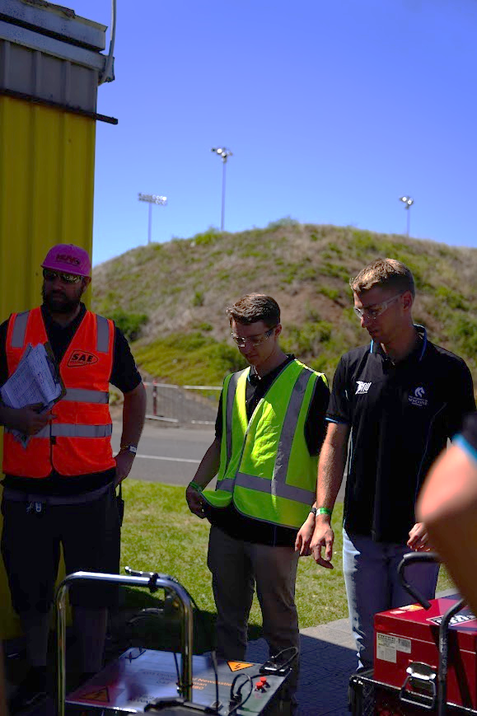

Figure 31 FSAE-A 2024 Accumulator Technical Inspection

Through the use of documents and samples, the accumulator will not have to be disassembled, only opened and with the service handle out, although the team should be prepared to take it off is necessary. 2023 was the first-year accumulator tech was run, and such every team was caught out by it. NU Racing was caught out by a main fuse rated too high, some sharp edges, some nuts had to be changed to nylon and an issue with a datasheet for the main HV connector, which was all replaced, and such all was considered in the 2024 design.

Every year the HV mat and gloves will need to be tested and tagged, as well as the 3-phase cable going into the charger. The ESO information on the accumulator and trolley will need to be updated with the current ESO too. All other changes should only come from new designs which should have been designed with the rules and TI in mind.

Changes that should be made in 2024 are new HV connectors that have a built-in interlock loop (HVIL) for AI.5.16 and a new voltmeter should be selected for AI.5.17. Not having the interlock meant a 3D-printed lock out had to be designed which covered the connectors which was a major oversight during the selection of the new connectors. The voltmeter is very old and barely works so it is worth getting a new one, or creating a functioning AIL early on in the year.

## EV Static (EV1)

EV Static is the first EV TI with the whole car and is a mix of demonstration and evidence providing. This TI can be taken with or without the accumulator if time is an issue but if time allows, the accumulator should be in. Everything that is needed for this TI is stated in the Bible before the first points, these include red stands to raise the car off the ground and high stands for the body kit.

The people required at this inspection are:

* Mechatronic TI Leader
* Mechatronic Department Lead
* LV Engineer (or experienced MCHA)
* Document and sample handler (experienced MCHA)
* Body kit team (4 designated team members) (standing outside the bay ready to help)

The team selection is less critical than accumulator tech but is still important that TI is rehearsed. During this TI the car must be lifted onto the red stand and such 4 people are needed to lift the car while two members position the stands, these should be the body kit team, and the two members should be the department lead and LV Engineer. Shortly after demonstrating the removal of the HVD (soon to be MSD), the body kit must also be removed, such the body kit team need to re-enter the back and assist. The top firewall should also be removed with a flat head screwdriver for better access to the electronics. There is a small change that the Structural equivalency schematic (SES) will be required too so a team member familiar with the document should have it opened on a computer.

The TI lead should be the first to introduce the team to the inspectors again but are not required to be the lead question responder. In 2024 the TI lead choose an experience MCHA to be the main question responder and instead followed along, ensuring all the documents and samples were ready when necessary. There is flexibility with how this TI is run and such should be chosen by the TI every year based off the current team. It is recommended to have a main question responder, a document and sample responder, the document hander and spare.

At the end of this inspection, it requires the grounding of all components need the tractive system and traditionally the inspector will not be happy and ask that a component which is not included on the list or logically makes sense is grounded. In 2023 it was the HVD bolts which mount to the enclosure, and such had to be fixed before passing. Luckily this issue is easily solved and only take a short amount of time to make grounding looms. It is recommended to ground absolutely everything in 100 mm of the track system in the future and to practise measuring everything with a Multimeter.

Every year majority of this TI will need to be reorganised as even small changes will require compliance inspection due to the stickers and markings required for this TI to be passed. The HV/LV separation document will need to be updated too, as this document features PCBs which are regularly updated, added or removed. A copy of the separation booklet can be found in Josh Hayward’s report. The energy metre supplied by SAE at competition will also need to be fitted before this inspection with instructions available on the SAE website.

It is recommended to have all the stickers and markings for the inspection ready as early as possible and with spares as in 2024 it was not passed until very late. The push bar should also be checked early on in case it needs modification.

## EV Functional (EV2)

EV functional can only be completed after Accumulator Tech, EV Static and Mechanical Tech and is the first time the car is switched on at competition. This is the simplest TI when rehearsed as it requires demonstration of the safety systems on the car and a small amount of supporting documentation. The safety systems are critical to the design of the car and can only be changed during it, as such all systems should have been operational for all of testing and such the pressure is low during this TI. The required members are the same as EV Static and the same tools are required, plug a laptop to show the BMS voltages and temperatures. The main difference is that the wheels will spin, and such the wheels must be taken off.

The people required at this inspection are:

* Mechatronic TI Leader
* Mechatronic Department Lead
* LV Engineer (or experienced MCHA)
* Document and sample handler (experienced MCHA)
* Body kit team (4 designated team members) (standing outside the bay ready to help)

The body kit team are to assist again with lifting the car onto stands and removing the body kit. The top firewall can remain on as there should be enough access to the BMS port and ideally the spare member in the bay can take the wheels off using the impact gun.

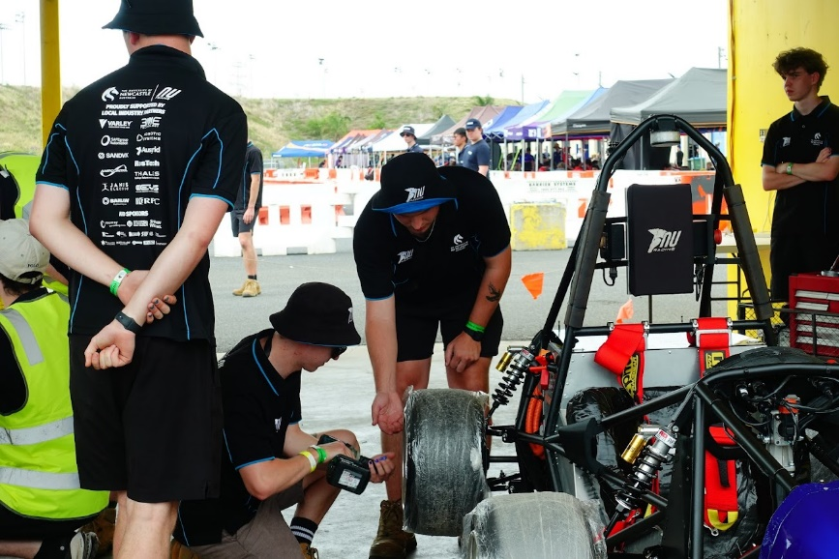

Figure 32 EV Functional at 2024 FSAE-A Competition

The roles are the exact same as Static, with a lot of option of who can do what and it is up to the TI leader to decide. During this TI, the team is given a fluke Multimeter to use and will be used to demonstrate the precharge and discharge times of the car and will also have to spin the wheels to demonstrate APPS TRAIL and PLAUS. To do this a low torque mode was used, setting the torque limit to 40 Nm so the speed of the wheels can be easily controlled so these can be easily demonstrated under pressure. The BSPD is also demonstrated using a power supply to induce current into a wire that is wrapped around the current sensor in the HIP, and such only requires LV to be on.

## Rain Test

## Competition

# 2024 FSAE-A Competition

# Conclusions and Recommendations

Wrap up the main points of your work and explain how it all fits together. Summarise your recommendations for how to make this component/system and how to design and manufacture new versions of this in future.

# References

# Appendix

## NU23 LV Systems

Topology:

NU Racing does not use a typical single electronic node like an ECU. This means that the car does not have one large single loom. Instead, we use several electronic nodes across the car, with individual looms running between the nodes. This allows for an easily serviceable system, splitting up vital aspects of the car onto individual PCB’s.

With this topology, the LV system is simple and intuitive and allows for the workload to be easily shared among different team members, each being able to focus on their individual board.

On NU23, the LV system includes:

* The Pedal Electronic Node (PEN): Reads the Brake Pressure Sensors, Accelerator Pedal Position Sensors (APPS), and Brake Over Travel Switch (BOTS)
* The Dash Electronic Node (DEN): Reads the Dash E-Stop and Ready-To-Drive (RTD) button, and relays PEN signals.
* The Central Electronic Node (CEN): Reads the Tractive System Master Switch (TSMS), Hard Fault Latch (HFL), Top E-Stops, HV and HV Disconnect (HVD) Interlocks, Brake System Plausibility Device (BSPD), Tractive System Active Light (TSAL), OK High Signals (OKHS) and Discharge Relay. Communicates to the DCDC, Motor Controller, REN, and Accumulator. (This board also is HV)
* Rear Electronic Node (REN): Read the Temperature Sensors of the Radiator, and relays Power to the Brake Light, RTD Sounder and Cooling Pumps and Fan.
* Low Voltage Distribution (LVD): Relays Power to the Accumulator Fans and Communicates Accumulator Temperatures from the Battery Monitor System (BMS) to the CEN as well as BMS OKHS. (This board also is HV)



Figure 33 NU23 LV Topology

The Topology of NU24 will be very similar to NU23, as it was very successful as a whole. Due to the new Cascadia Motor Controller’s inbuilt coolant temperature sensors, the REN has become obsolete and such the power switching functionality has been moved to the CEN. The CEN has also been split up into two separate LV and HV boards, with the LV board remaining as the CEN and the HV board now becoming the Human Interface Panel (HIP), featuring the Master Switches, HVD and Test Points.

Shutdown Circuit:

The shutdown circuit is the most important LV circuit on the car, ensuring that the tractive system is discharged if any safety parameter within the rules is compromised.

A highly detailed explanation of the shutdown circuit and everything related can be found in the rules although it is not vehicle specific.

NU23’s shutdown circuit consists of:

* Brake Over Travel Switch (BOTS): Placed behind the brake pedal in such a way that if the hydraulic brake system of the car fails, the driver will be able to flip this switch, turning off the tractive system.
* Inertia Switch: This has to be placed in a vertical position on the car (on the steering gearbox on NU23) and will turn the shutdown circuit open in the event of a crash (8 – 11g).
* Dash E-Stop: This is an emergency stop button on the DEN, easily accessible by the driver, and is the easiest way to turn off the tractive system from within the car.
* TSAL E-Stops: Two emergency stop buttons on either side of the main roll hoop on the car. This is the main mode of turning the car off from the outside.
* HVD interlock: The HVD is an easily accessible High Voltage disconnect on the car (on the CEN on NU23) and as this is directly connected to HV, an interlock is used to monitor if it is disconnected.
* Hard Fault Latch Interpose: This is a latch on the CEN board which goes bad if any of the OKHS go bad. These signals are BMS, PRECHARGE, IMD, BSPD, and DISCHARGE. This latch activates an interpose relay which is directly connected to the shutdown circuit (the latch isn’t).
* TSMS: This is on the CEN enclosure and is the tractive system master switch.
* HV Interlocks: These are the same as the HVD interlocks but are for the HV connectors between the CEN and Accumulator.

Once all of these are good, the Precharge relay and Accumulator Isolation Relays (AIRS) will open to turn on the tractive system.



Figure 34 NU23 Shutdown Circuit Schematic (found in NU23 GITHUB)

The shutdown circuit of NU24 has changed, starting in the PEN now, and removing the HFL Interpose for the HFL itself. The HV interlocks are also no longer needed.

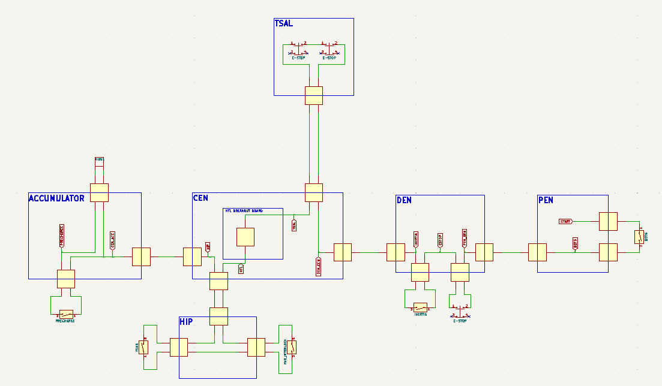

Figure 35 NU24 Shutdown Circuit Schematic (found in NU24 GITHUB)

Hard Faults:

Displayed on the driver’s display via the shift lights.

* Precharge Discharge Open Circuit (PDOC):

This hard fault is triggered when communication is lost with the Precharge circuit and/or the discharge circuit. The discharge circuit must be wired in a way that it is always active when the shutdown circuit is open and must be able to handle the maximum tractive system voltage for a least 15 seconds. The Precharge circuit is supplied by the Shutdown circuit and must be able to charge the immediate circuit to 90% of the accumulator voltage before closing the second AIR. If any these events do not occur or the circuits are disconnected in anyway, the hard fault is triggered, turning the Precharge or Discharge OKHS bad. The precharge board is located on the top plate and is communicated by the LVD. The discharge circuit in apart of the CEN on NU23 and will be on the HIP on NU24.

* Insulation Monitoring Device (IMD):

This device monitors for an insulation failure within the tractive system, and it checks to see that the device itself is working properly. If either of these events occur, the IMD_OKHS goes bad. This device is located on the top plate of the accumulator and is communicated by the LVD.

* Accumulator Monitoring System (AMS):

The AMS must measure the temperatures of critical points within the accumulator, ensuring that the maximum cell temperature does not exceed 60° C. It also must ensure that at least 20% of the cells have temperature monitoring. If the temperature readings drop below 20% or reads temperatures higher than 60° C, the AMS_OKHS goes bad. This comes from the Orion BMS on the top plate and is communicated by the LVD.

* Brake System Plausibility Device (BPSD):

The BSPD monitors the average brake pressure between the two pressure sensors read by the PEN and the current of the electric motor to ensure that the shutdown circuit opens when the accelerator and brake pedal are pressed at the same time. Both the brake pressure and current draw have selected values, which if both are exceeded at the same time, make the BPSD_OKHS go bad. The BPSD circuit is located on the CEN.

## Detailed Design Review (DDR)















## NUCAN Zero-To-Hero

**NUCAN ZERO-TO-HERO**

NUCAN is the NU Teams standard use medium for CAN BUS, featuring a DBC file and C++ scripts which generate a library of short cuts to allow for easy and efficient use of CAN BUS within code.

Instead of writing the information of each CAN BUS signal, NUCAN allows for a message to be sent with a single line of code. Setting up the CAN BUS code is also easier and NUCAN comes with some added functionality like heartbeat, internal CPU temperature sensing on Teensys and WATCHDOGS.

The WATCHDOG is built into NUCAN and does not need to be turned on, it will monitor the Teensy’s heartbeat signal and reboot it if there is any problem. This means a heartbeat signal is needed for NUCAN to work.

**The NUCAN GitHub:**

The NUCAN GitHub repository is where all of NUCAN is stored for all teams.

There is a folder of all the DBC files as well as individual libraries for each DBC file within the folder.

The build_cpp_from_dbc.py file is a script which turns the DBC file, which humans can easily interact with, into C++ code that Arduino IDE uses. Whenever a new DBC file is added or removed this file needs to be updated. **Line 4 is the only line that needs to updated to represent the DBC files within the DBC Files folder.**

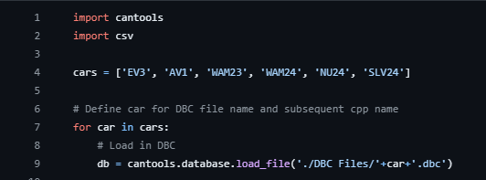

Figure 36 build_cpp_from_dbc.py Script

Whenever this repository is ‘pulled’, the libraries which aren’t being used by the Arduino code need to be deleted to avoid error when verifying or uploading the code to a teensy. An example of this is when using the NU24_CAN.h file, all other DBC created .h and .cpp files, e.g. WAM23.cpp, WAM23.h must be removed from the user’s local device EXCEPT InternalTemperature, Watchdog_t4 and NUCAN.

**HOWEVER, DO NOT push these deleted files as changes back to GitHub if changes to a DBC file are made. This will remove all the other files from the GitHub.**

Whenever a change is made to a DBC file, NUCAN needs to be pushed to update the C++ files, then pulled. It may take a second for script to run fully and update the C++ files.

Creating and editing a DBC file:

To create a new DBC file or edit an existing one, either copy the format of an older DBC file (recommended) or create a new one from scratch using Kvaser Database Editor 3, which is a CAN message editor (DOWNLOAD: <https://kvaser.com/single-download/?download_id=47183> ).

It is recommended to edit and create new DBC by copying what was already done before. There are many examples in GitHub within the DBC folder and it is important to get familiar with these before trying to edit and create new DBC files. Refer back to CAN BUS ZERO TO HERO to ensure that the DBC file format is understood.

Using the Kvaser Editor for DBC files:

The Kvaser Editor will format everything, and it is recommended to look and understand an existing DBC file (revise back to CANBUS ZERO TO HERO) before making changes or creating a new file to minimise mistakes.

Once the format and interface is understood, create new CAN messages using the plus icon in the ‘Messages & Signals’ tab in the top box. To add signals within a single CAN message, use the bottom box (this is what is specific to each signal, so consideration needs to be made).

Ensure there is a heartbeat message for each node as the Teensy’s WATCHDOG needs a heartbeat signal to function.

Once the DBC file has been created or edited, it can then be saved/exported and save to the NUCAN DBC file folder and then added to the build_cpp_from_dbc.py file, before being pushed to GitHub and pulled shortly after.

Before using the DBC file and the generated libraries, double check everything was correctly created or use first in a very safe matter.

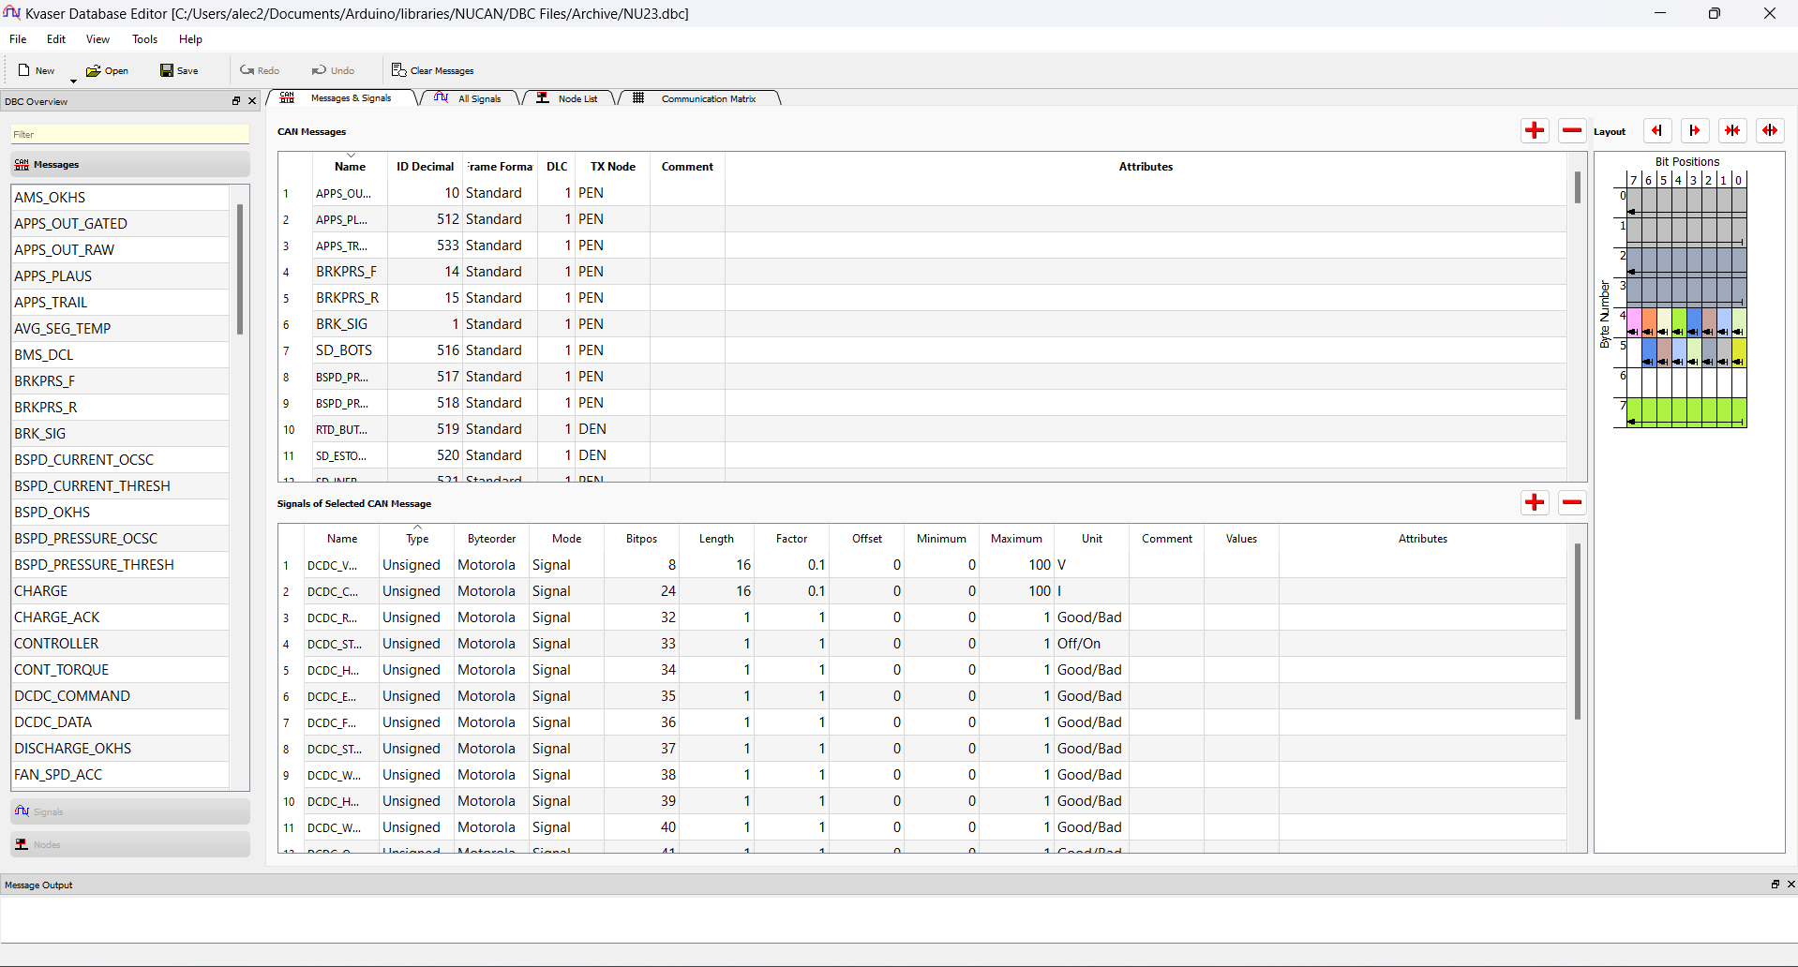

Figure 37 NU23 DBC file in Kvaser Database Editor

**Using NUCAN on Arduino IDE**

Set up:

Arduino requires the NUCAN library files to be in its libraries folder. The easiest way to ensure it can always find NUCAN is to put the whole NUCAN folder in the Arduino libraries folder (typically found in *User>Documents>Arduino*).

You also need to delete the other unused library files, e.g. SLV24.cpp and SLV24.h as described above now (if you are unsure, ask for help). You can see what files you need to delete by verifying your code, the trouble files will be displayed as an error.

Defining a Library:

Before reading or writing CAN messages with NUCAN, the respective header file for whichever variant of NUCAN you want to use must be included at the top of the Arduino script using ‘#include <(*file_name.*h)>’.

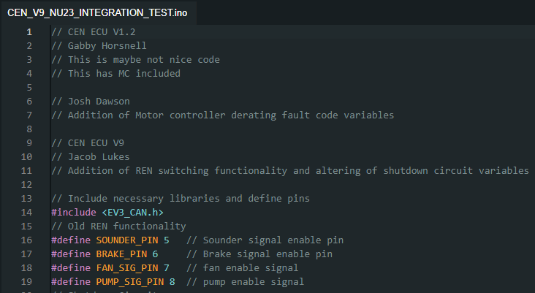

Figure 38 EV3_CAN.h Defined in CEN CODE

The example above uses the EV3 library.

Note: NUCAN does not need to be defined as it is included within each library.

CAN Variable:

Next the variables which NUCAN uses needs to be created. NUCAN requires the number of messages its receiving, sending, and the name and variable to store the value of the received messages.

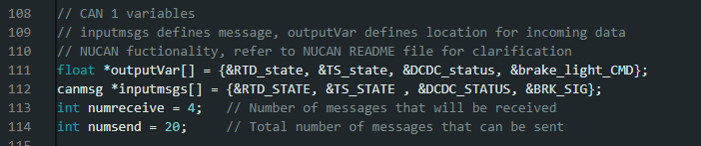

Figure 39 NUCAN Variables in CEN CODE

This is a good example of how to do this, as 4 messages are received, and their values are sorted into variables which were defined earlier in the code.

outputVar[] is an array of variables, these are where the received messages will be sorted for use within the code.

inputmsgs[] is an array of CAN BUS message names, these are the message to be read from the bus.

numreceive is the number of messages that NUCAN expects to read from the CAN BUS.

numsend is the number of messages that NUCAN expect to write onto the CAN BUS.

NUCAN Initialisation:

Now NUCAN variables have been created, NUCAN can be initialised in the ‘void setup()’ section of the code using ‘NUCAN_init(numsend, numreceive)’.



Figure 40 NUCAN initialised in CEN CODE

Above is an example of doing this. NOTE in this example the bus speed is set by NUCAN based on the CANBUS_speed.csv file in the DBC folder.

To set the bus speed manually, simply define the bus speed as a variable prior and include it as the third variable within the NUCAN_init function e.g. NUCAN_init(numsend, numreceive, bus_speed).

Reading messages using NUCAN:

As the number and names of the variables of the received messages have already been defined, NUCAN only needs to be told to read the BUS and update these variables using NUCAN_read(outputVar, inputmsgs, numreceive). This should be within ‘void loop()’.

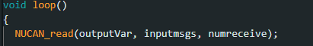

Figure 41 Using NUCAN_read in CEN CODE

Writing messages using NUCAN:

Once a variable is made and has a value, it is now ready to be sent using NUCAN_write(). To use this function, put the name of the signal you want this variable to update and then the variable. This name should be identical to the name used in the respective DBC file.



Figure 42 Using NUCAN_write in CEN CODE

In the code above, a variable is defined from a digital read of a pin and then written to the bus using a NUCAN_write().

Using the NUCAN Heartbeat:

To call the NUCAN Heartbeat function, simply include NUCAN_heartbeat() within the void loop() section of the script.



Figure 43 Using NUCAN_heartbeat in CEN CODE

In this example, a heartbeat signal is sent to the CAN BUS using a message name specific to that node (i.e. ‘&HB_CEN’).

**IMPORTANT: A heartbeat signal is necessary for NUCAN to work as the WATCHDOG will reset the Teensy if it does not see a heartbeat.**

Using the NUCAN internal temperature:

This function writes the current CPU temperature of the Teensy. To use it, call NUCAN_Core_Temp() with the specific CAN BUS message name from a respective DBC, just like NUCAN_heartbeat.

e.g. NUCAN_Core_Temp(&LVD_CORE_TEMP).

Include this line within the void loop() section of the code.

By Alec Chapman 3/7/24

## 2024 ESF

The submitted document can be found in Teams

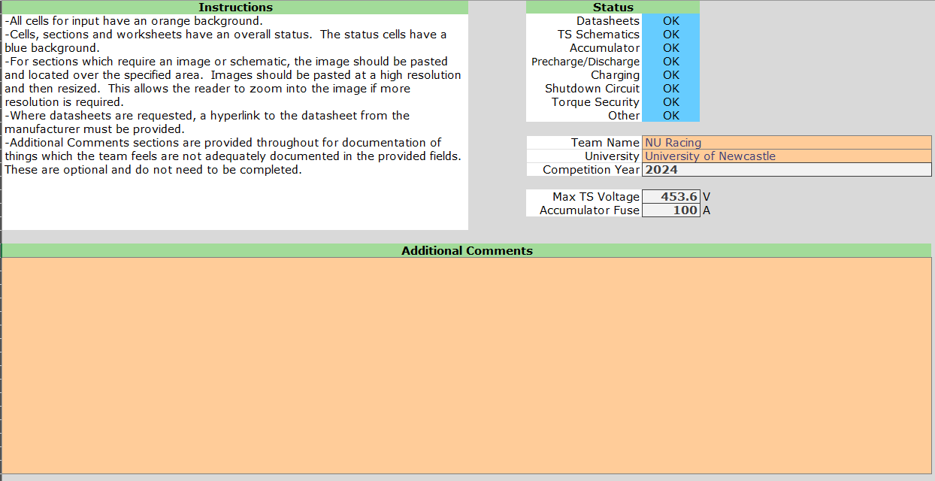

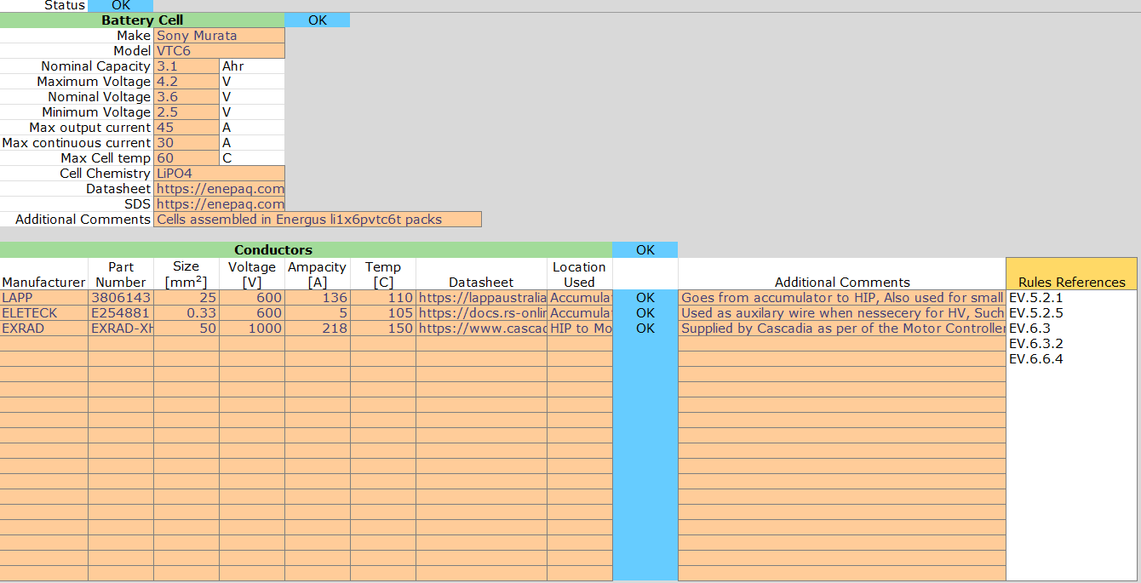 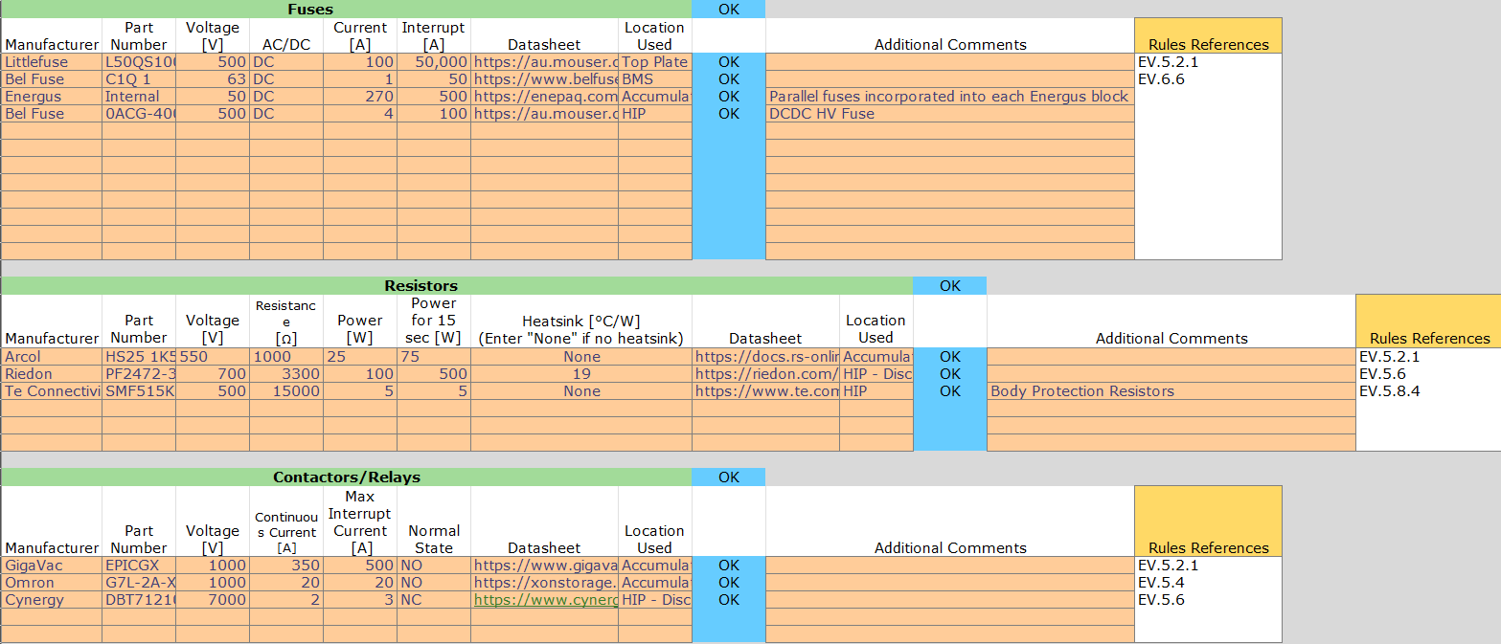

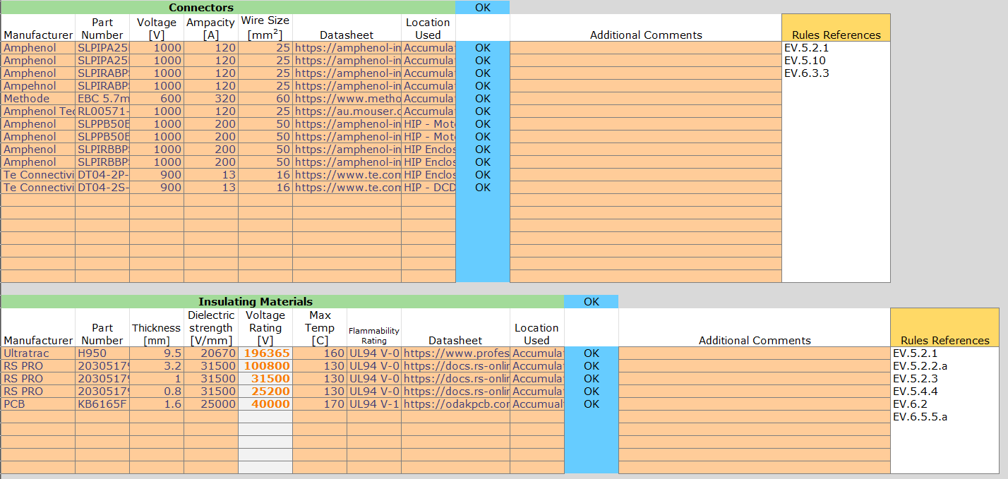

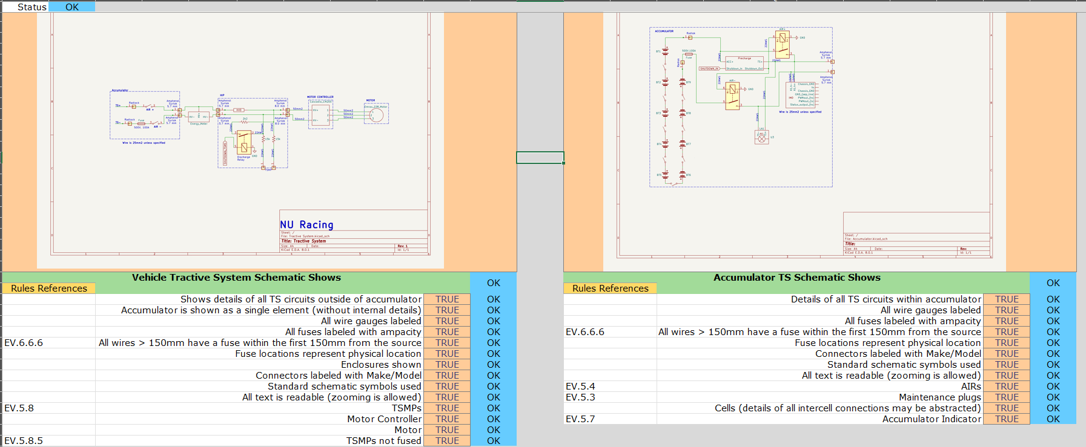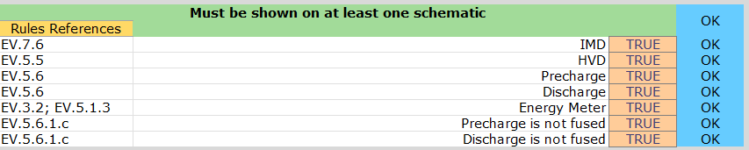

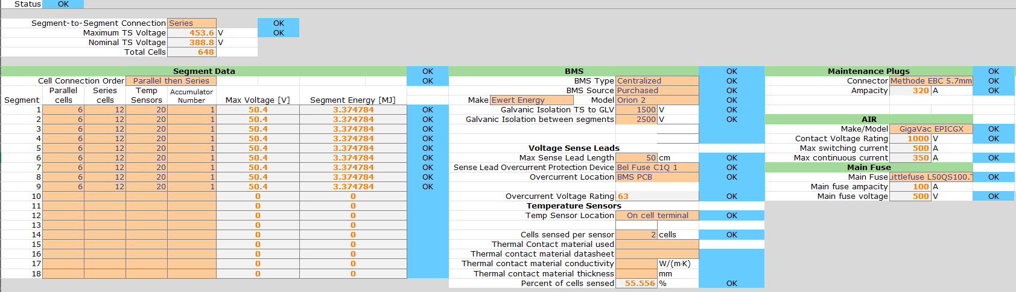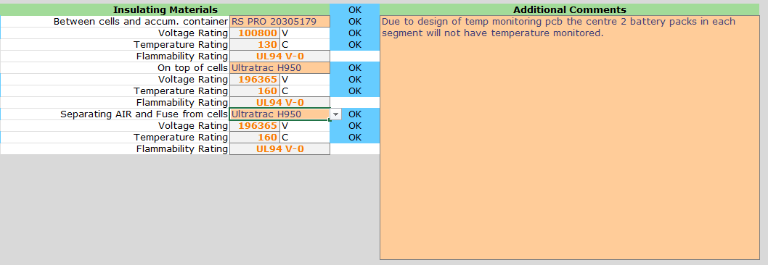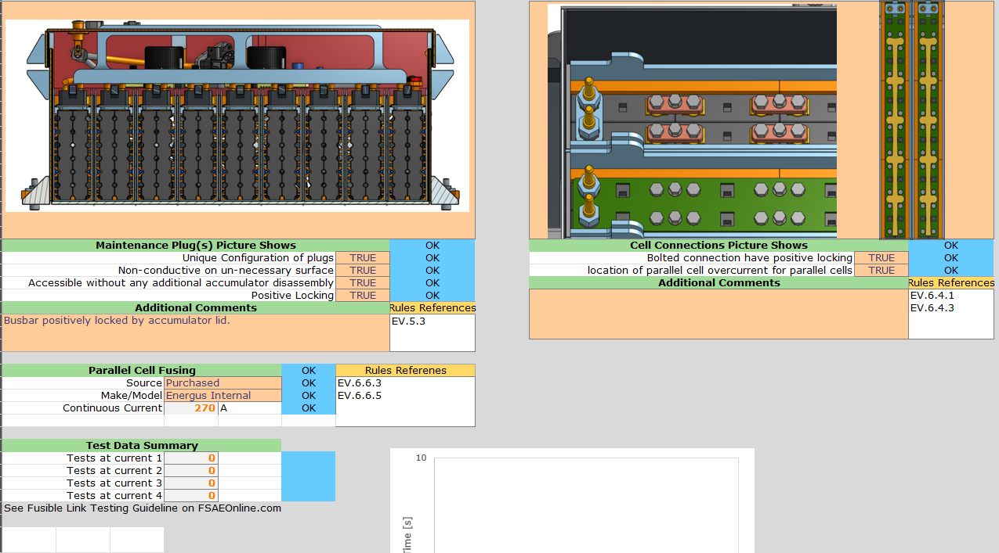

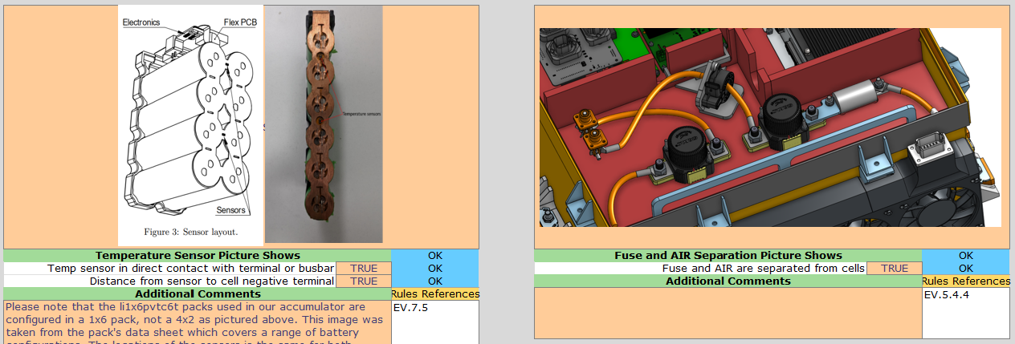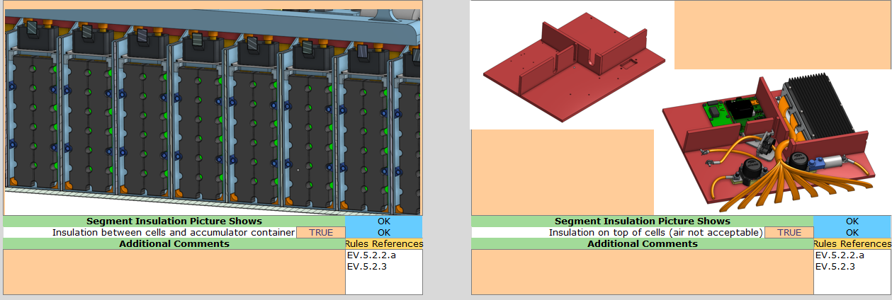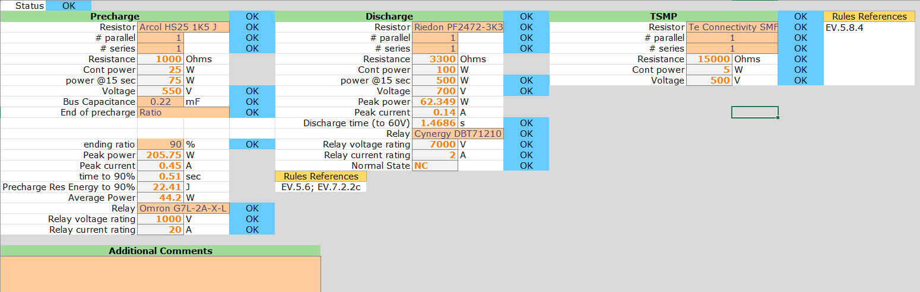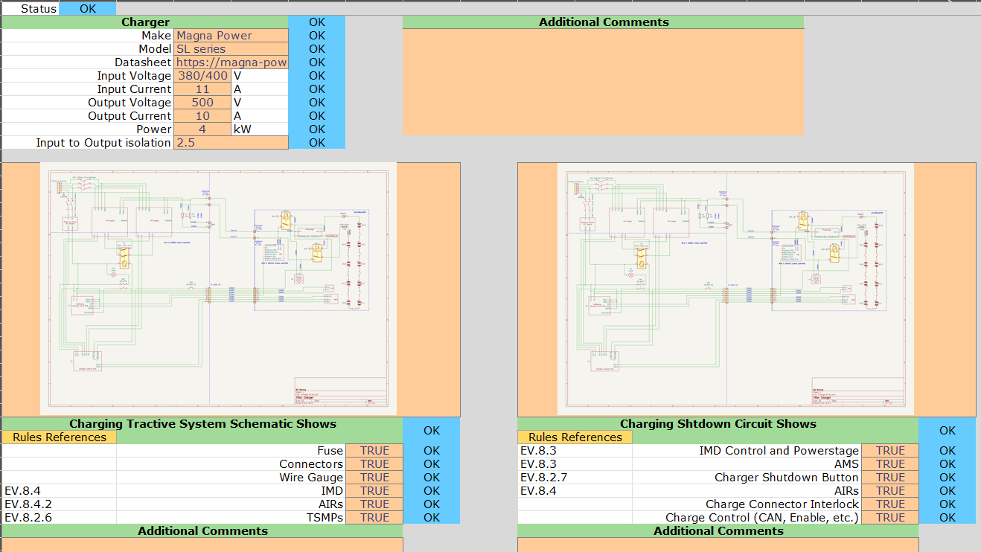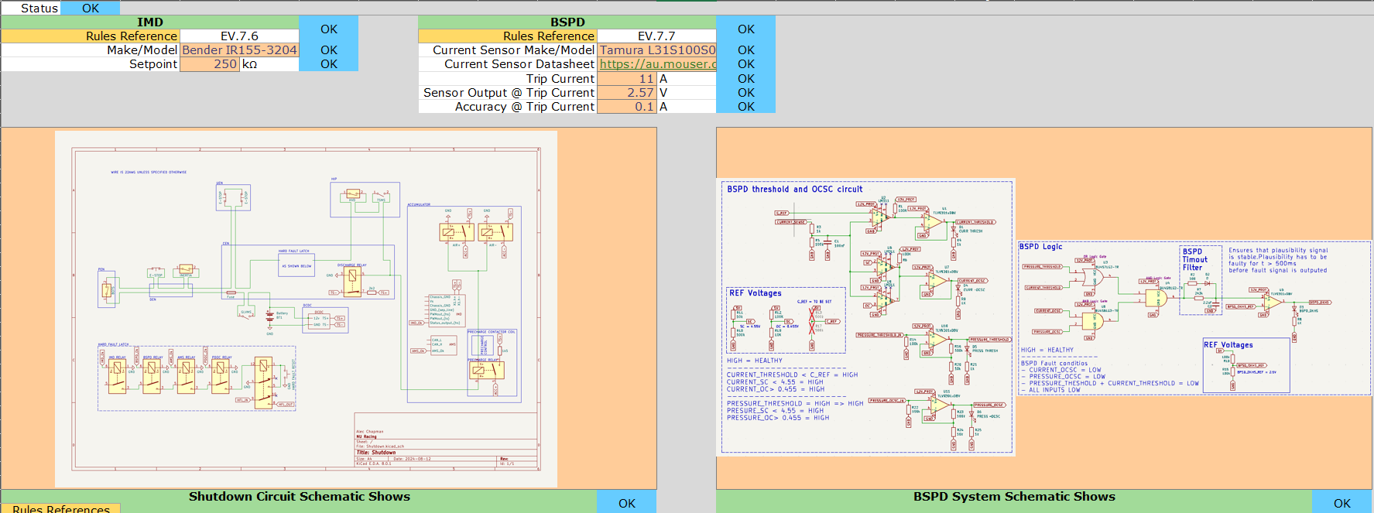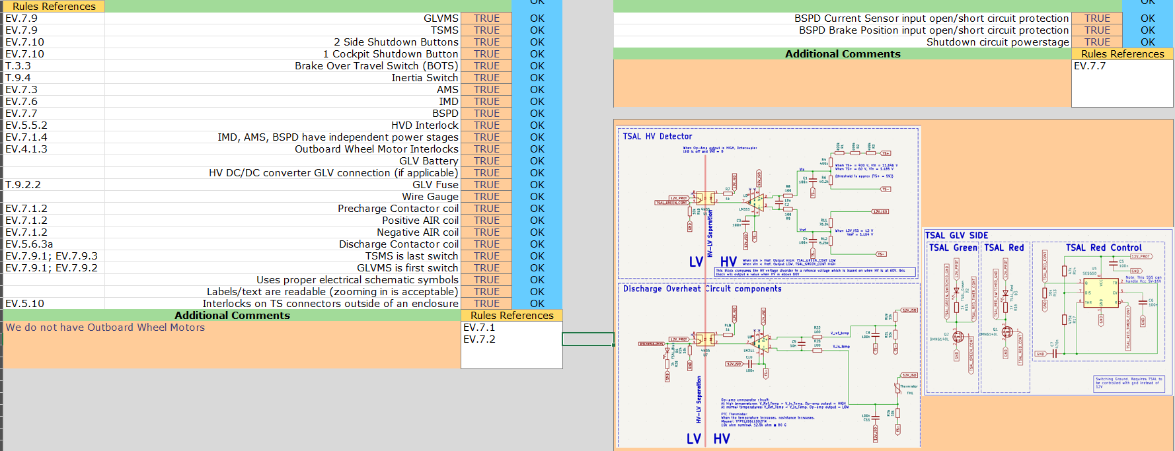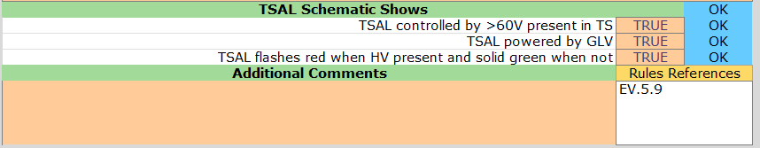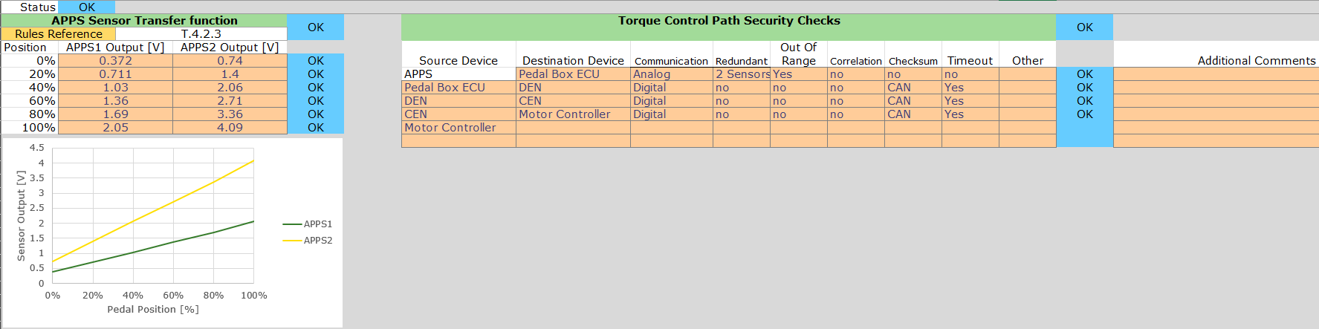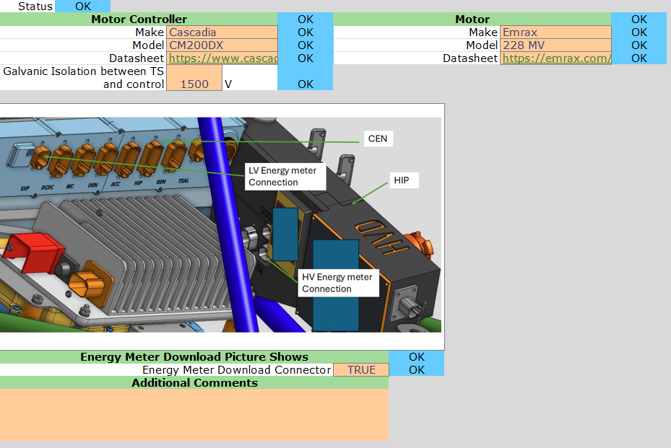

## Cost Report











































































































































## The Cost Scenario Presentation

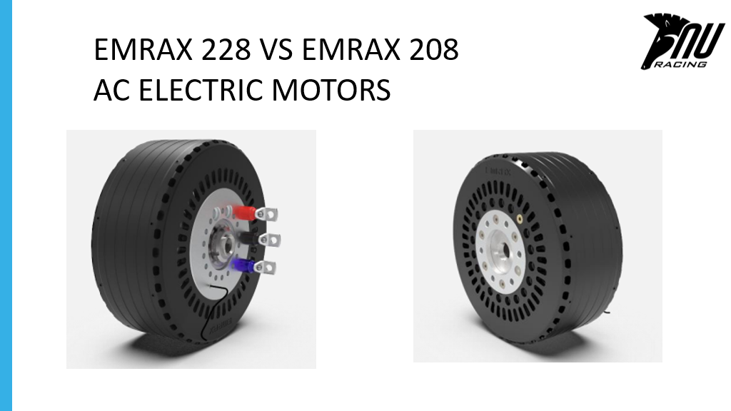

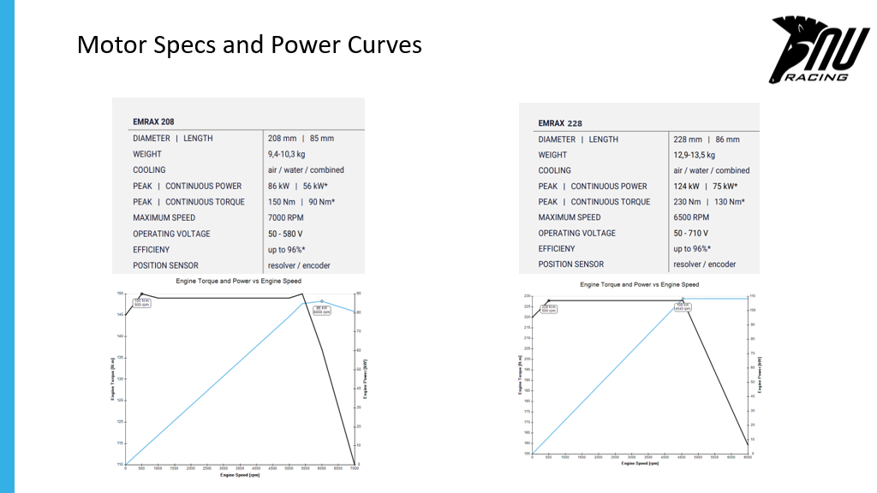

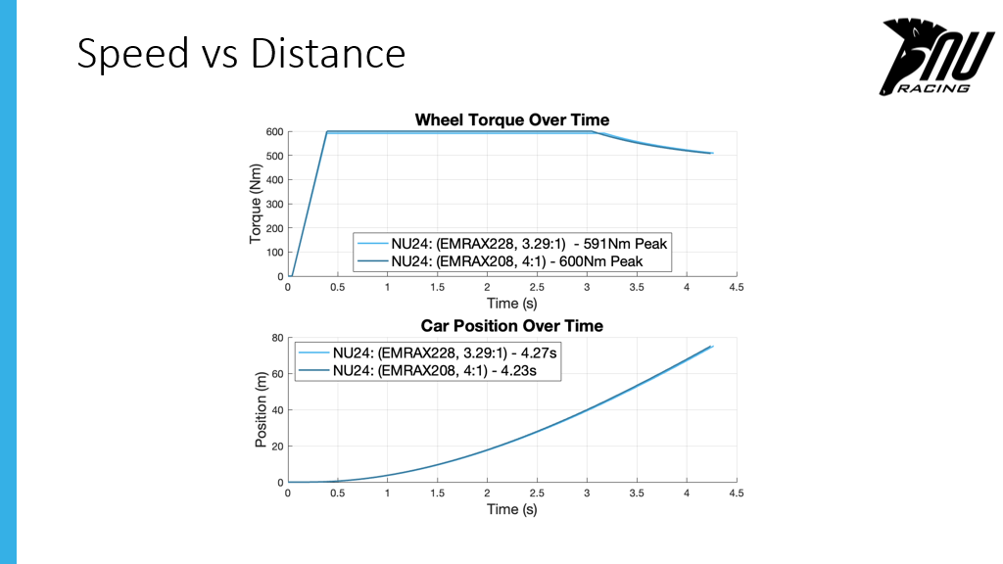

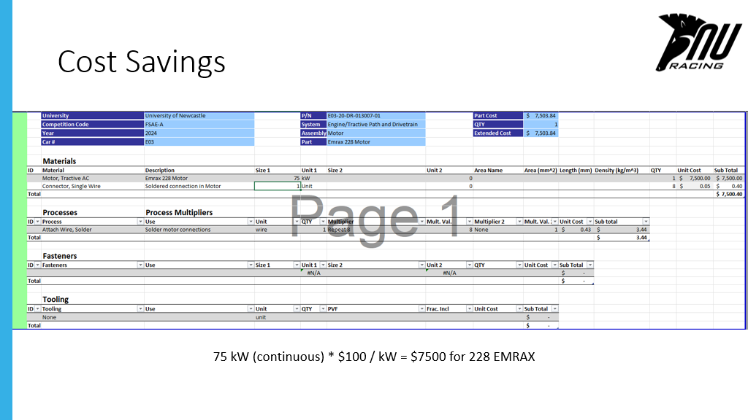

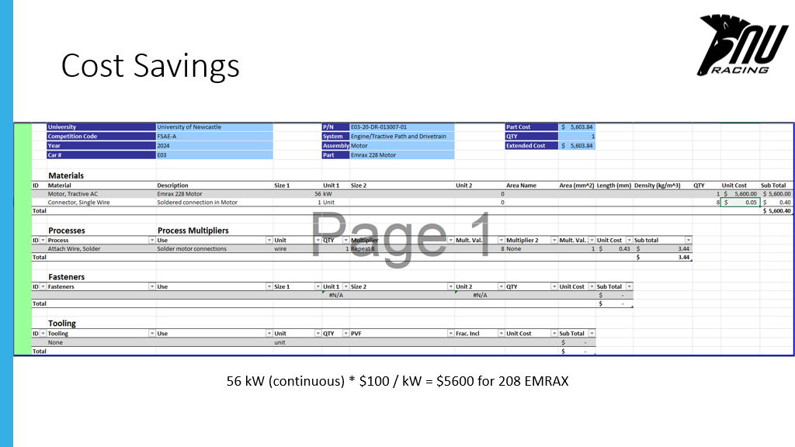

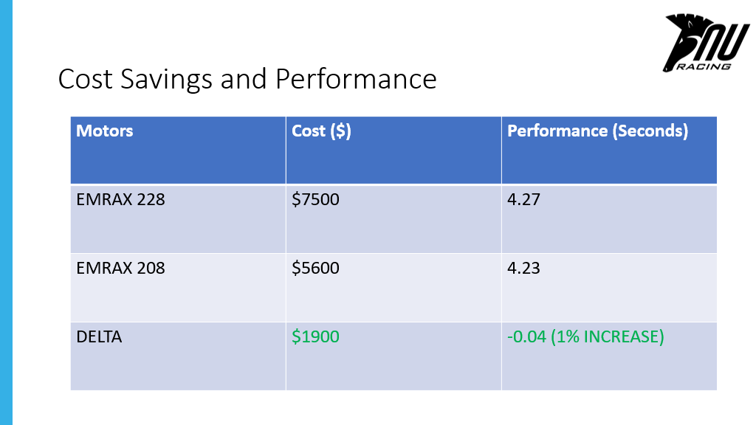

## The MCHA Technical Inspection Bible:

